**Task on vpc-01.**

**===============================================**

1. **Create VPC with 2 private and 2 public subnets.**

* Open Amazon console and search for VPC
* Open vpc and click on create VPC
* Then select VPC only and provide tag name (eg.My-VPC) and IPV4 block id as IPv4 CIDR manual input
* IPv4 CIDR provide your own CIDR (eg:172.168.0.0/24)
* IPv6 CIDR keep No
* Click on create VPC
* Then will get Unique VPC id
* Now create 2 public and 2 private subnets
* Open VPC in left side section we can fine subnet tab click on that provide the details
* Select vpc id created by you not which existing and provide subnet name(eg:My-pub-subnet1)
* Select availablity zone (eg:now it is in **eu-north-1a select next subnet as 1b)**
* IPv4 VPC CIDR block select which is created by you and
* Provide IPv4 subnet CIDR should be (eg:VPC 172.168.0.0/24 subnet 172.168.0.0/28)
* Click on create subnet
* Likewise create My-pub-subnet2 and My-pri-subnet1, My-pri-subnet2For My-pub-subnet2, you should select Availability Zone 1b.
* And for My-pri-subnet2, you should select Availability Zone 1b and My-priv-subnet1 in 1a.
* You will have one public and one private subnet in each AZ (1a and 1b), which helps with high availability and fault tolerance.
* Pub-subnet1-----172.168.0.0/28-172.168.0.63/28
* Pri-subnet1-----172.168.0.64/28-172.168.0.127/28
* Pub-subnet2-----172.168.0.128/28-172.168.0.191/28
* Pri-subnet2-----172.168.0.192/28-172.168.0.255/28

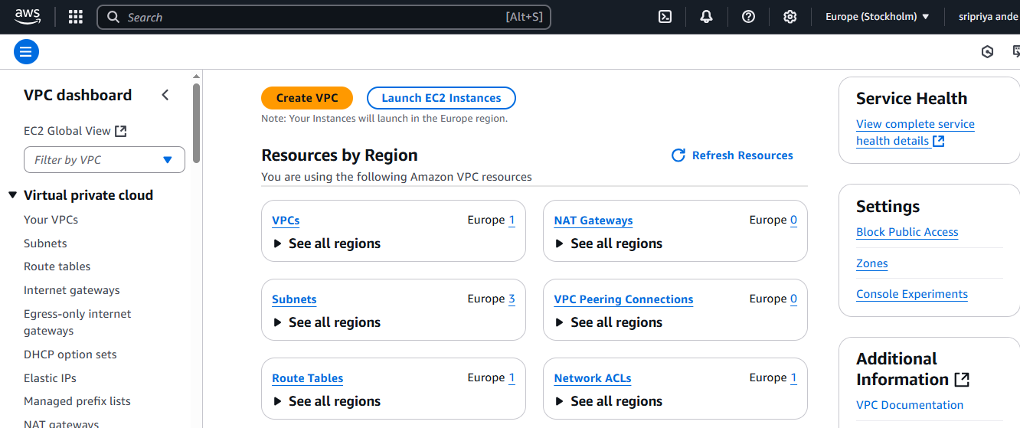

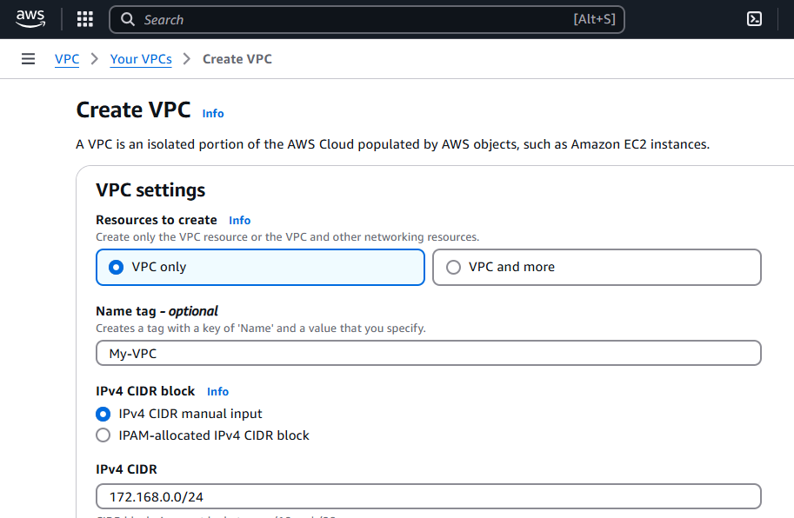

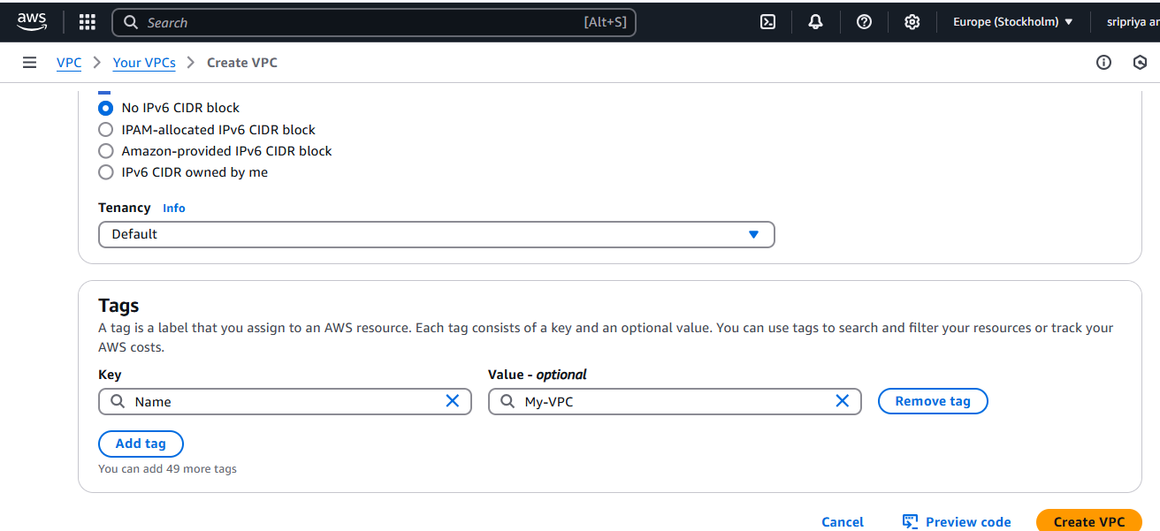

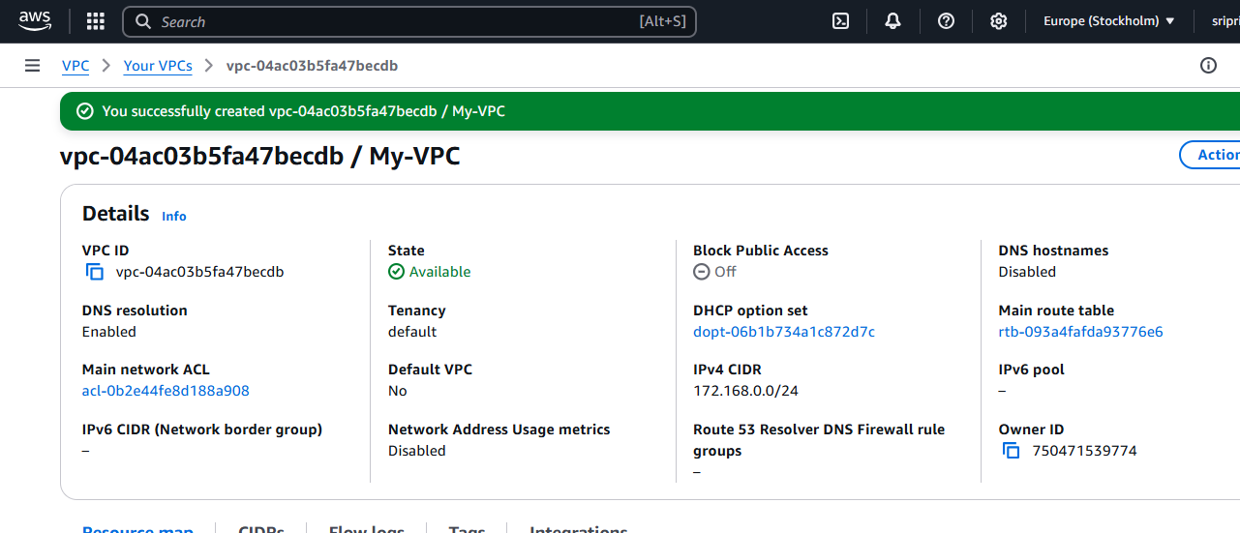

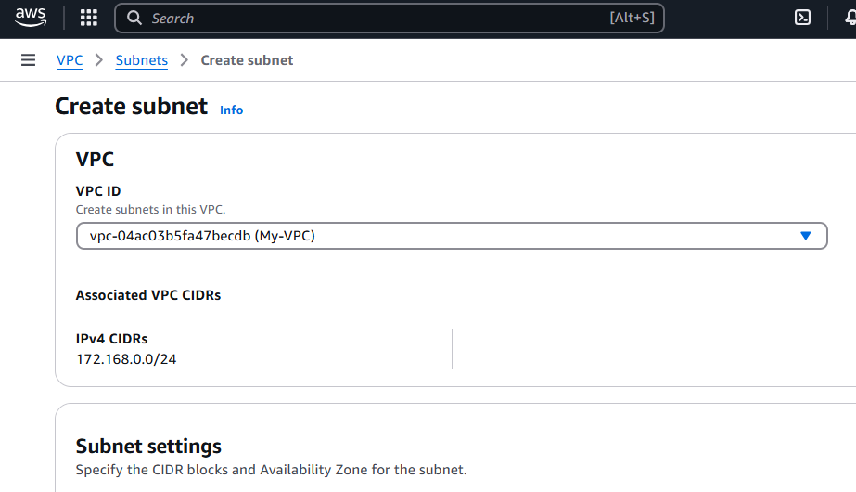

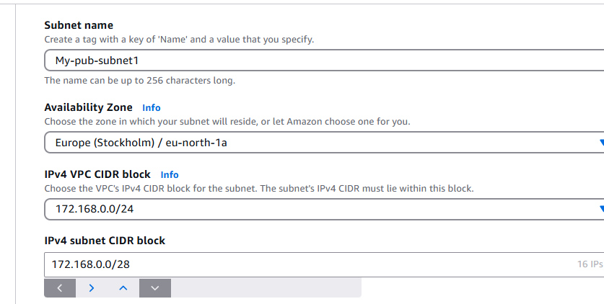

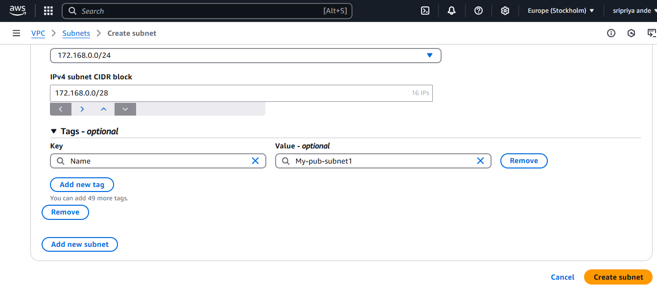

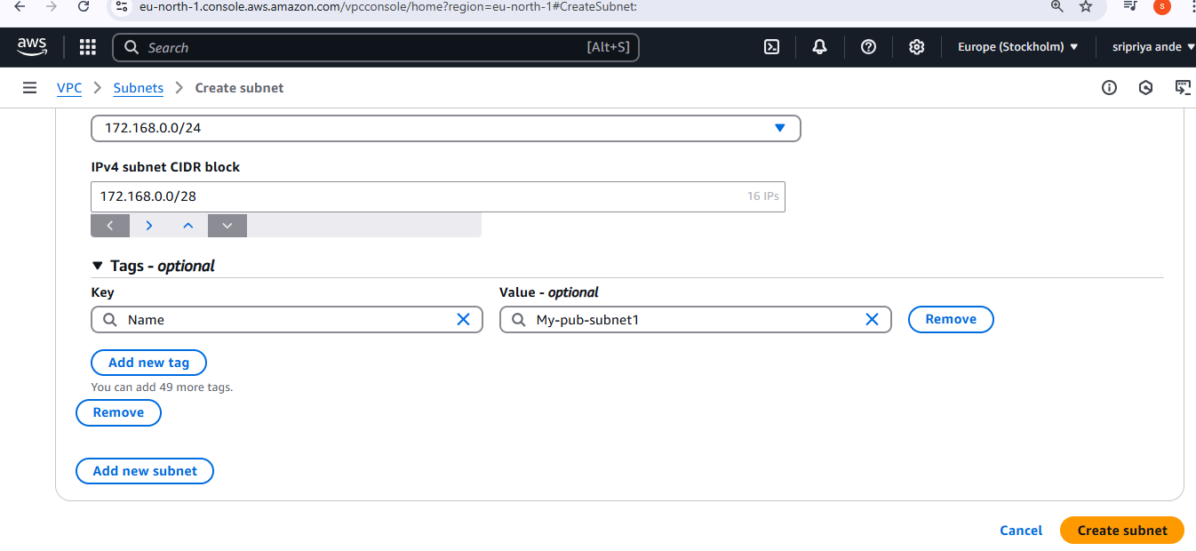

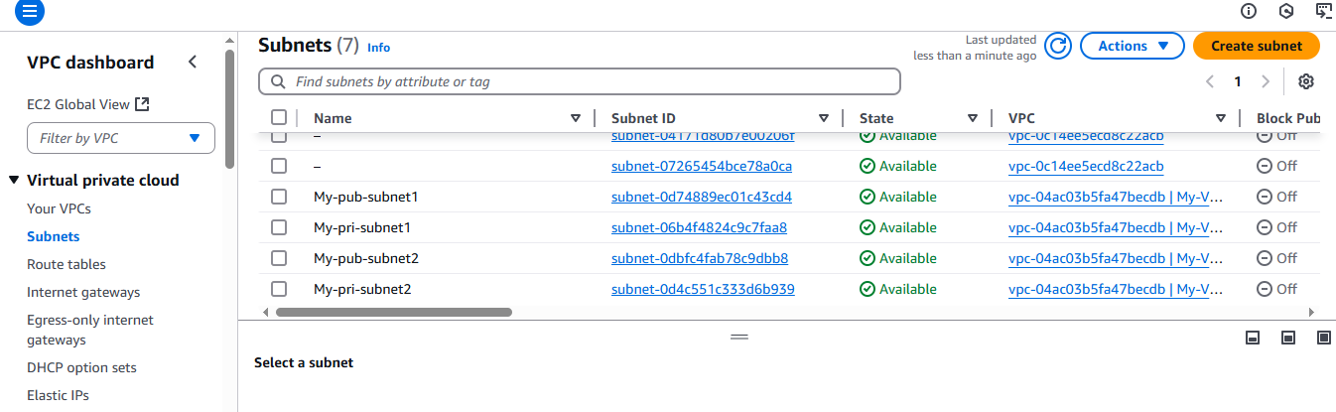

1. **Enable DNS Hostname in VPC**

DNS stands for Domain Name System.

DNS is like the phonebook of the internet — it translates domain names (like google.com) into IP addresses (like 142.250.72.14), so that browsers and applications can locate and connect to websites and services.

**To enable DNS hostnames in a VPC in AWS, follow these steps:**

Your VPC must have DNS resolution enabled (it is enabled by default).

You're using a custom VPC, not the default one (DNS hostnames are enabled by default in default VPCs).

**Steps to Enable DNS Hostnames:**

Go to the AWS Management Console

Open https://console.aws.amazon.com/vpc

Select “Your VPCs” from the left-hand menu.

Choose your VPC from the list.

In the lower panel, click on the "Actions" dropdown.

Select "Edit VPC settings".

Enable the checkbox for:

✅ Enable DNS hostnames

Click Save changes.

**Notes:**

This setting is important if you're launching EC2 instances in that VPC and want them to be reachable by public DNS names (like ec2-54-123-45-67.compute-1.amazonaws.com).

Useful especially in public subnets for bastion hosts or public-facing applications.

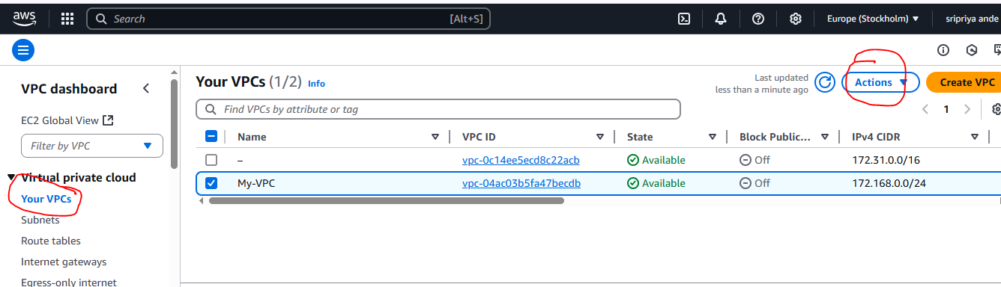

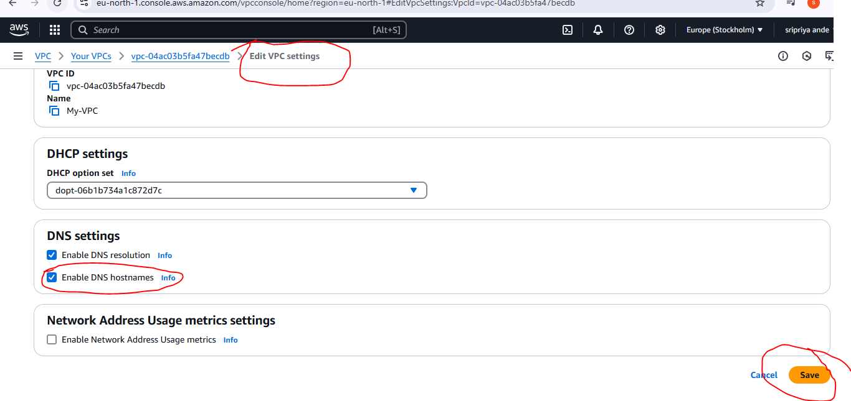

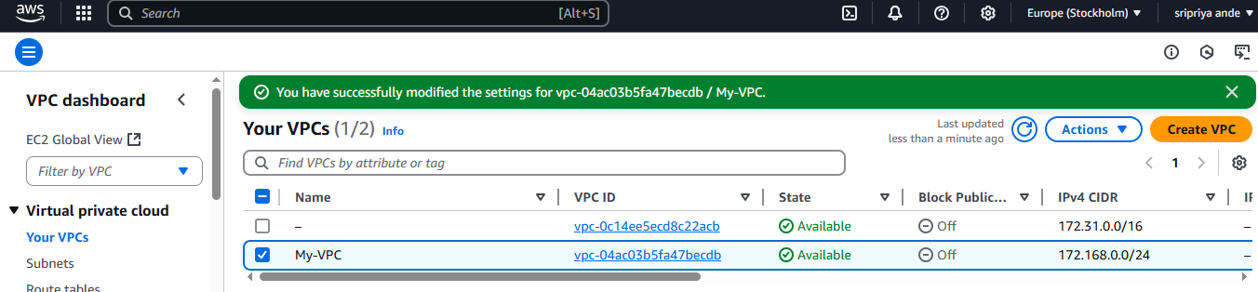

1. **Enable Auto Assign Public ip in 2 public subnets**

**To enable auto-assign public IP in your 2 public subnets on AWS, follow these steps:**

**Steps to Enable Auto-Assign Public IP:**

Open AWS VPC Console:

https://console.aws.amazon.com/vpc

In the left-hand menu, click on “Subnets”.

Select the first public subnet from your list.

Click on “Actions” → “Edit subnet settings” (or “Modify auto-assign IP settings”).

Under “Auto-assign public IPv4 address”, enable the checkbox:

✅ Auto-assign IPv4 address

Click Save changes.

Repeat the same steps for the second public subnet.

**What This Does:**

When this setting is enabled, any EC2 instance launched in that subnet (without specifying a network interface) will automatically get a public IP address, making it accessible from the internet (if security groups allow it).

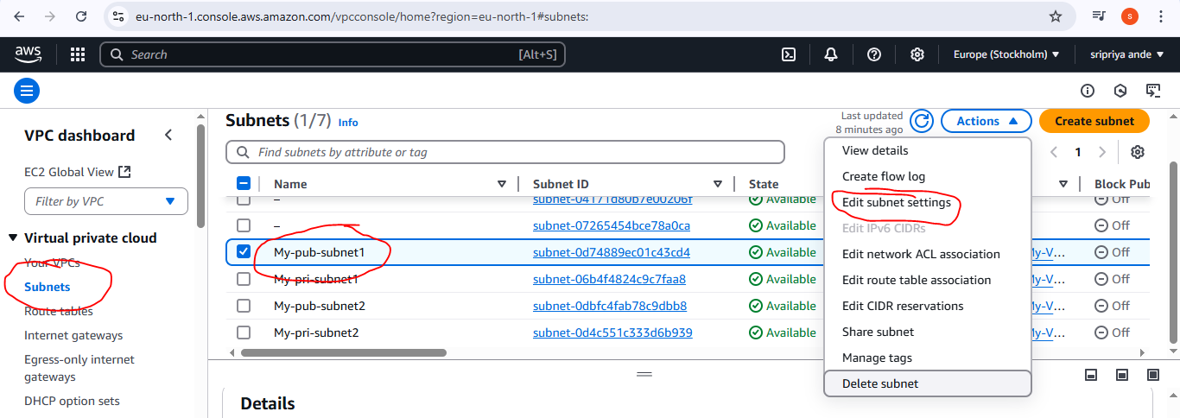

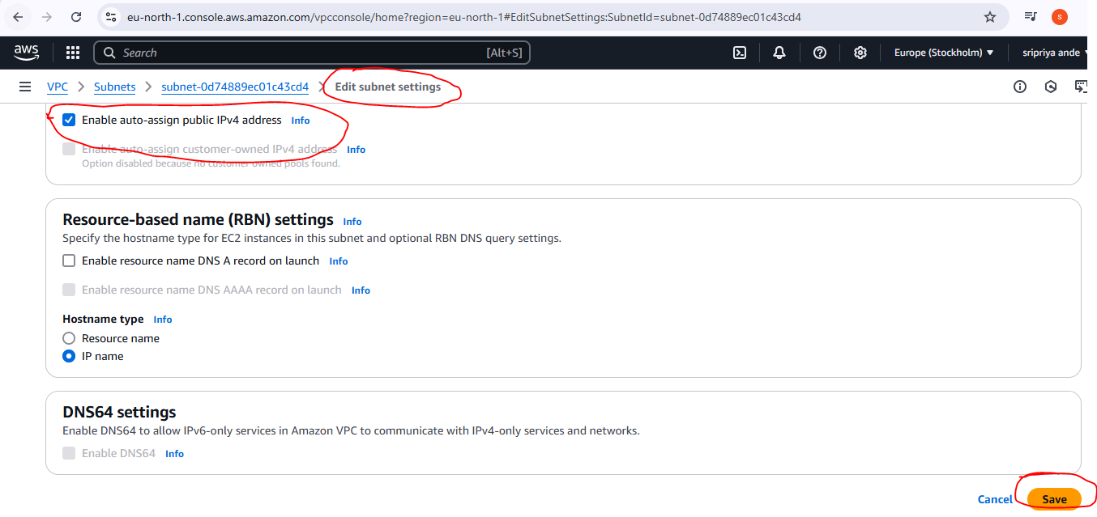

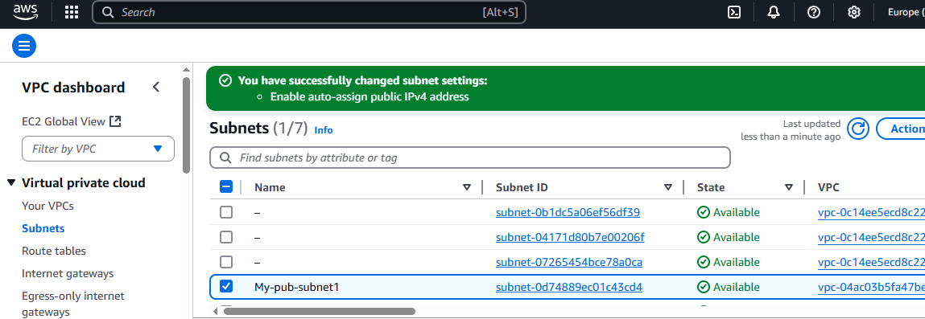

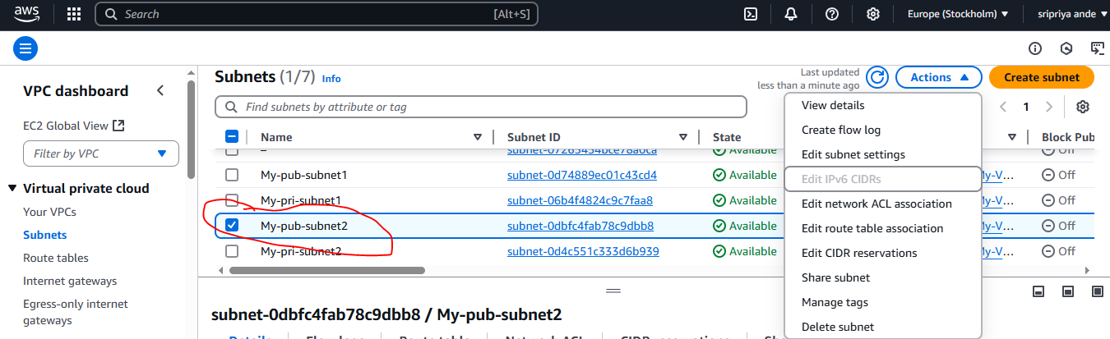

1. **Add 2 private subnets in private route table**

**To add 2 private subnets to a private route table in AWS, follow these steps:**

Initially Go to route tabel and create RT with PVC(eg:My pvc)Then follow below steps

You should already have a VPC, 2 private subnets, and a private route table created.

The private route table should NOT have a route to the internet gateway (IGW), only a local route or NAT Gateway if required.

Steps to Associate Subnets to Private Route Table:

Go to the VPC Dashboard:

https://console.aws.amazon.com/vpc

In the left menu, click on “Route Tables”.

Find and select your Private Route Table (look for the one without a route to IGW).

Scroll down and go to the “Subnet associations” tab.

Click Edit subnet associations.

From the list of subnets, select the two private subnets you created.

Click Save associations.

**Result:**

Now, the selected private subnets will use the private route table for routing. They won't have direct internet access unless you set up a NAT Gateway in a public subnet and add a route to it.

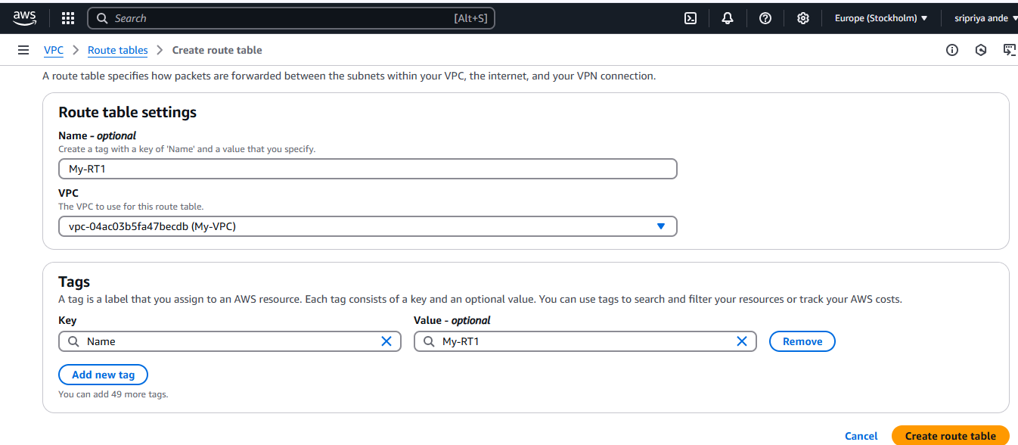

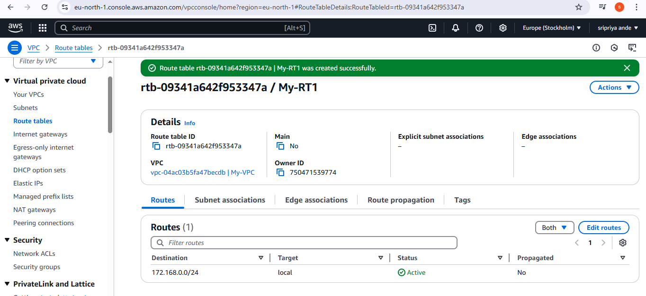

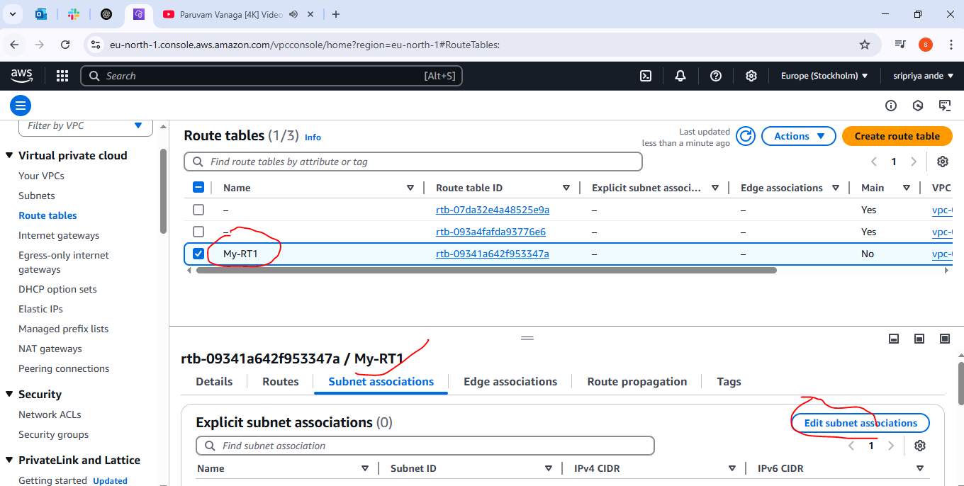

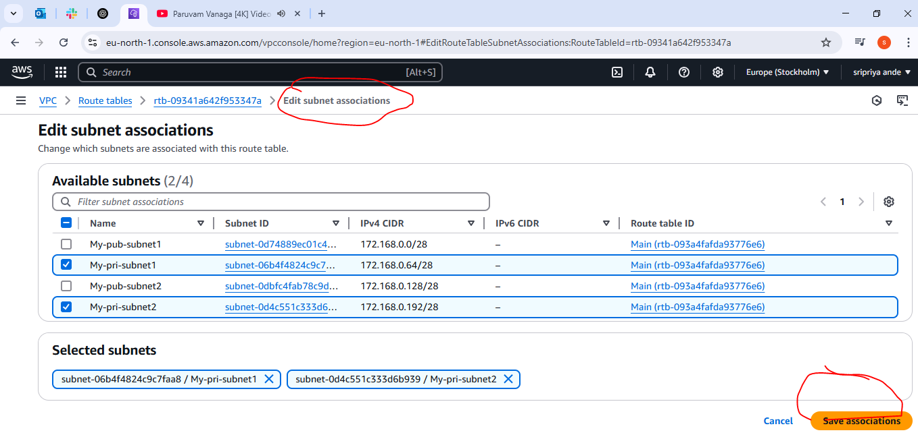

1. **Add 2 public subnets in public route table**

**Here's a step-by-step guide to create an Internet Gateway (IGW) and associate 2 public subnets to a public route table in AWS:**

**Create an Internet Gateway**

Attach it to your VPC

Create or update a public route table

Add a route to 0.0.0.0/0 via the IGW

**Associate 2 public subnets with this route table**

**Step-by-Step Instructions**

**Step 1:** Create an Internet Gateway (IGW)

Go to VPC Dashboard in AWS Console:

https://console.aws.amazon.com/vpc/

In the left menu, click Internet Gateways.

Click Create Internet Gateway.

Name it (e.g., my-igw)

Click Create Internet Gateway

After creating it, click Actions > Attach to VPC

Choose your VPC (e.g., 172.168.0.0/24)

Click Attach

**Step 2:** Create (or use existing) Public Route Table

In the VPC Dashboard, click Route Tables.

If you already have a public route table:

Click on it to open.

Or, create a new one:

Click Create route table

Name it (e.g., Public-RT)

Select your VPC

Click Create

**Step 3:** Add Route to IGW

Select the Public Route Table (the one you just created or selected).

Click the “Routes” tab > Edit routes

Click “Add route”:

Destination: 0.0.0.0/0

Target: Choose Internet Gateway > Select your IGW (e.g., igw-xxxxxx)

Click Save changes

**Step 4:** Associate Public Subnets

Go to the “Subnet associations” tab of your Public Route Table.

Click Edit subnet associations.

Select the 2 public subnets (e.g., 172.168.0.0/26 and 172.168.0.64/26).

Click Save associations

Your 2 public subnets are now connected to the public route table, which routes to the internet via the IGW.

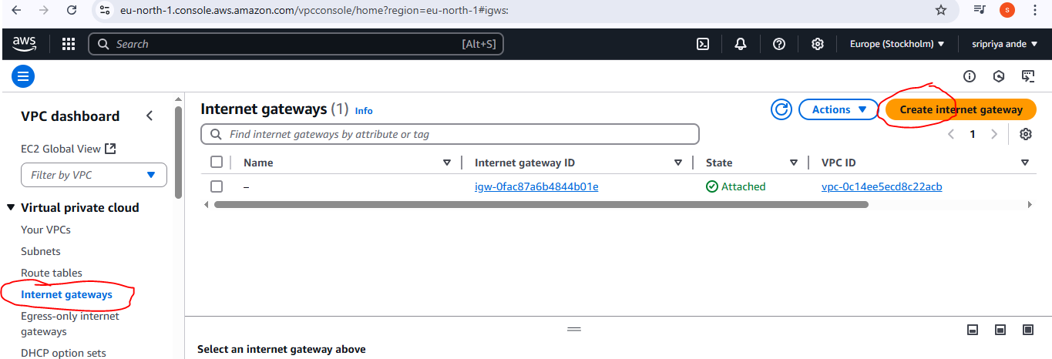

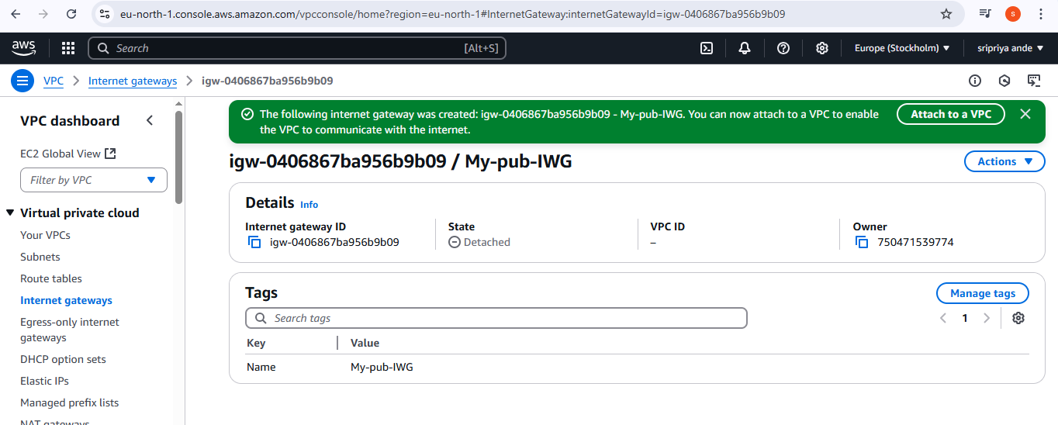

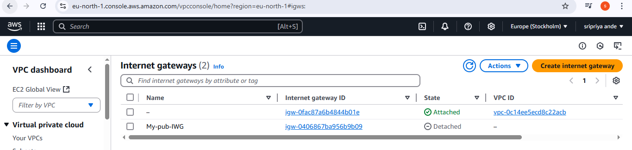

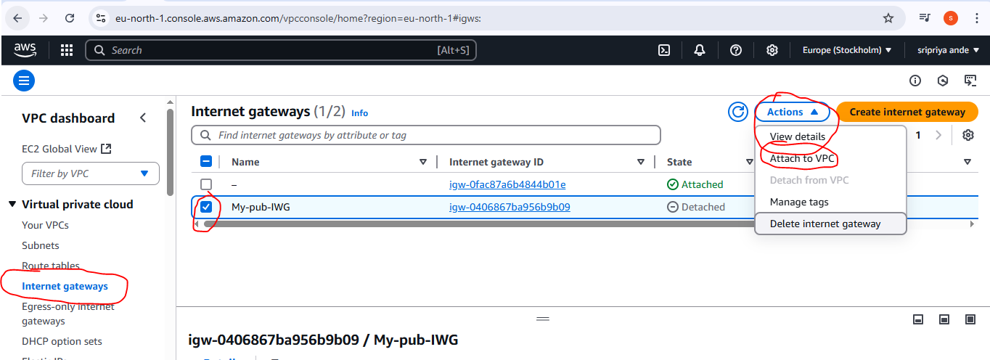

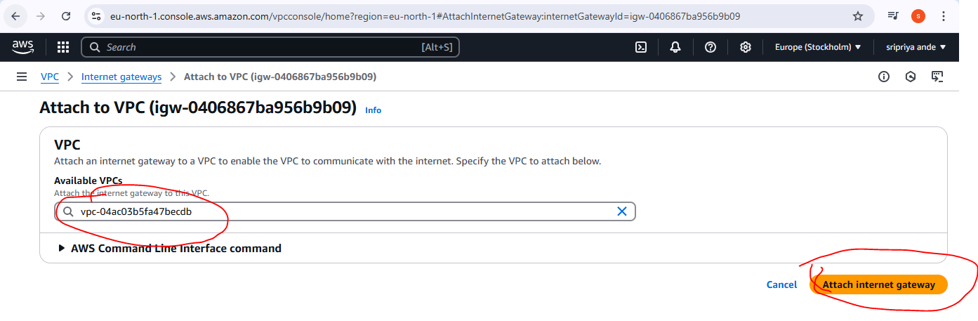

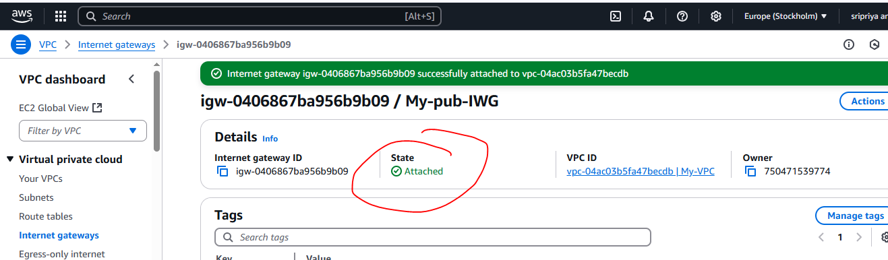

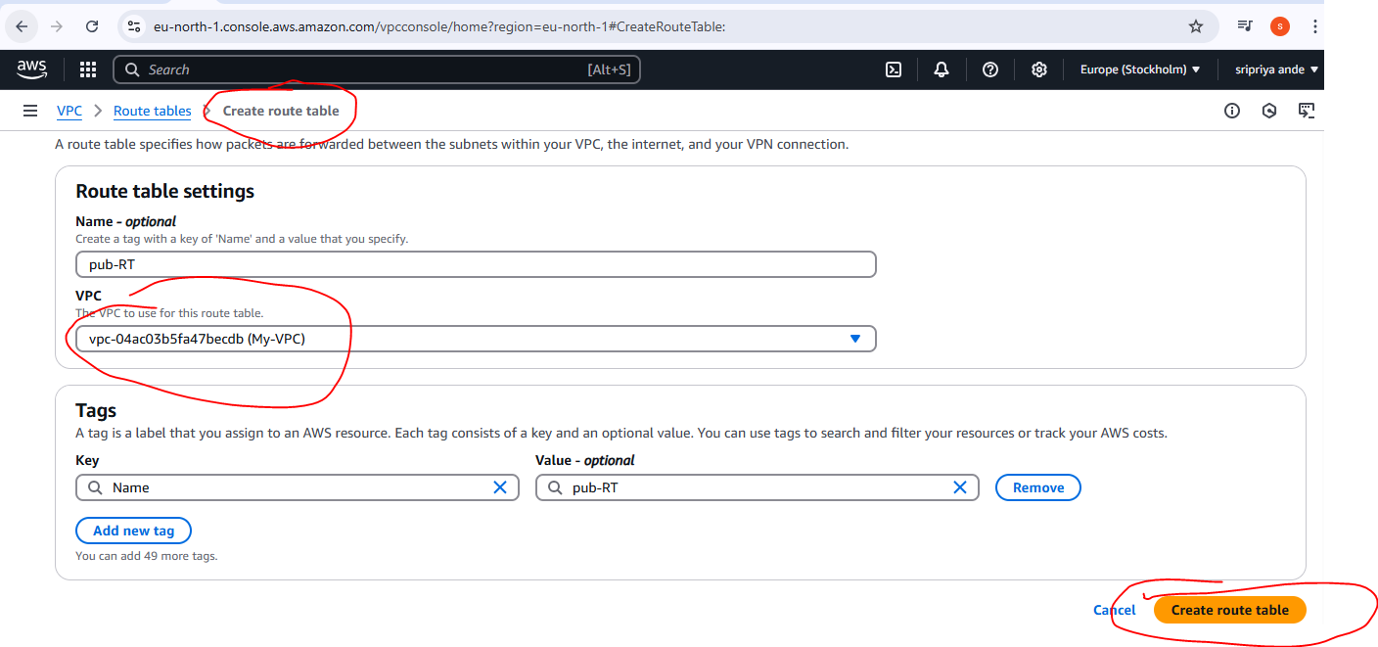

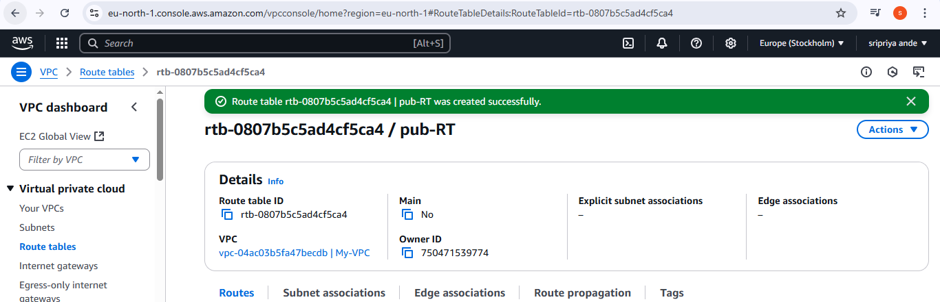

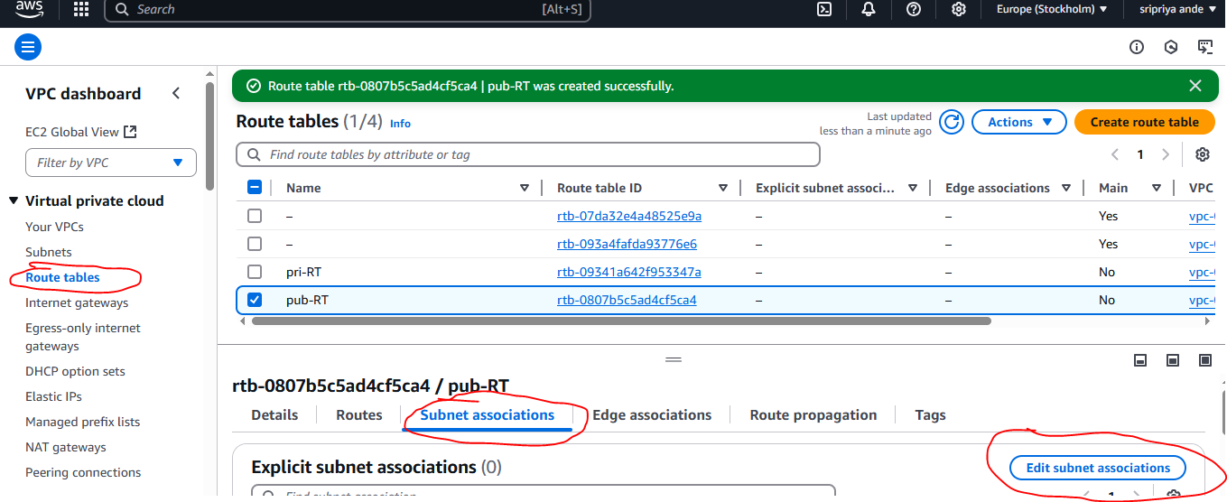

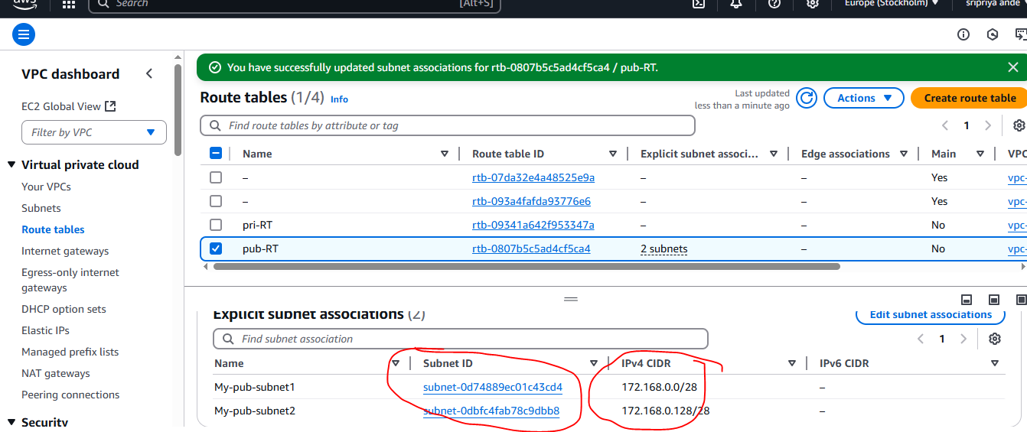

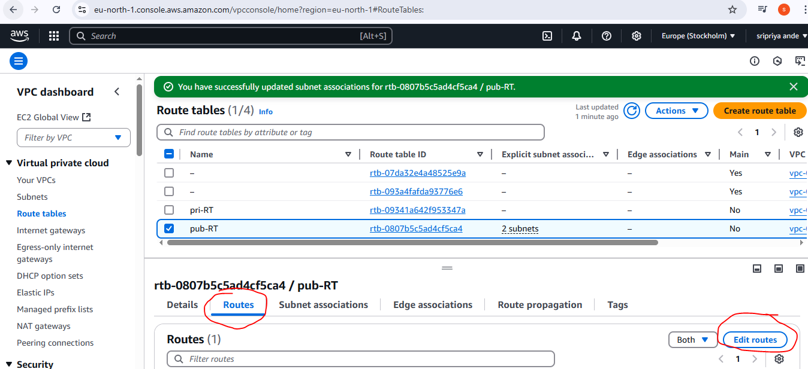

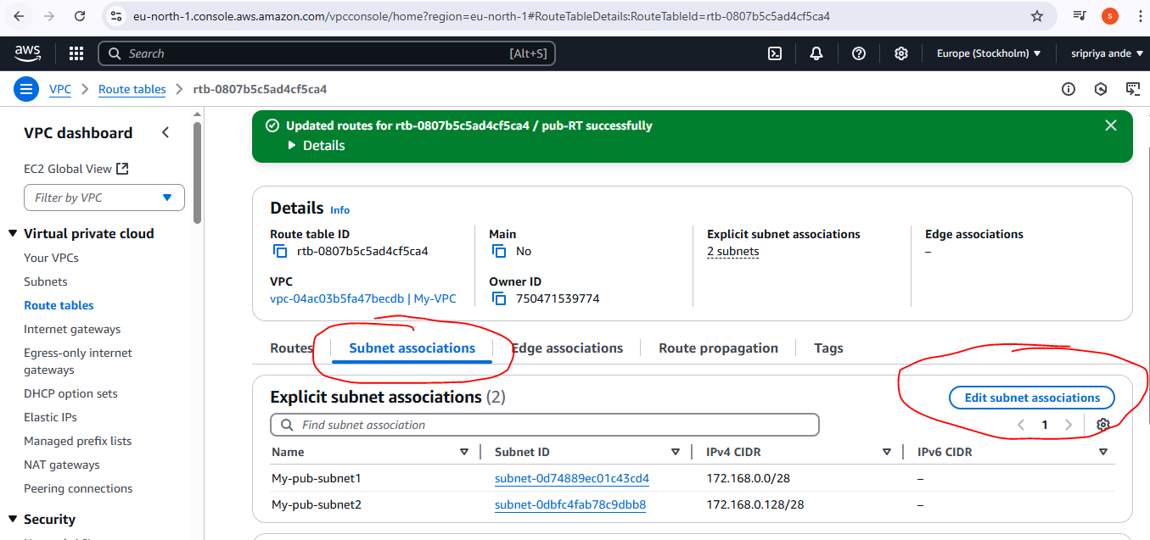

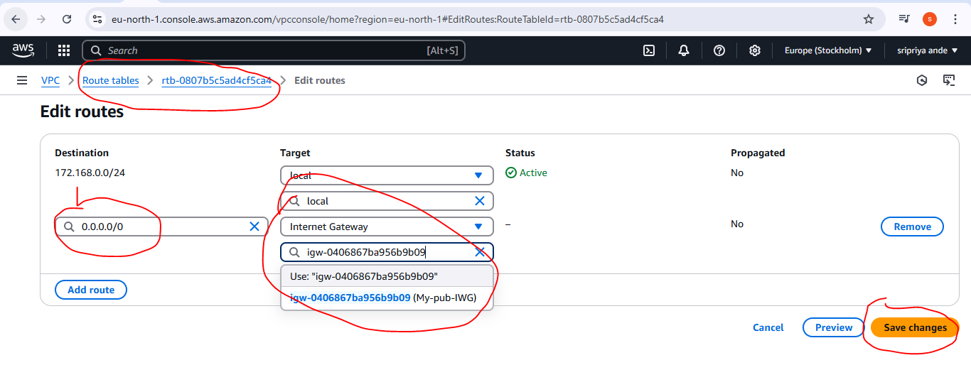

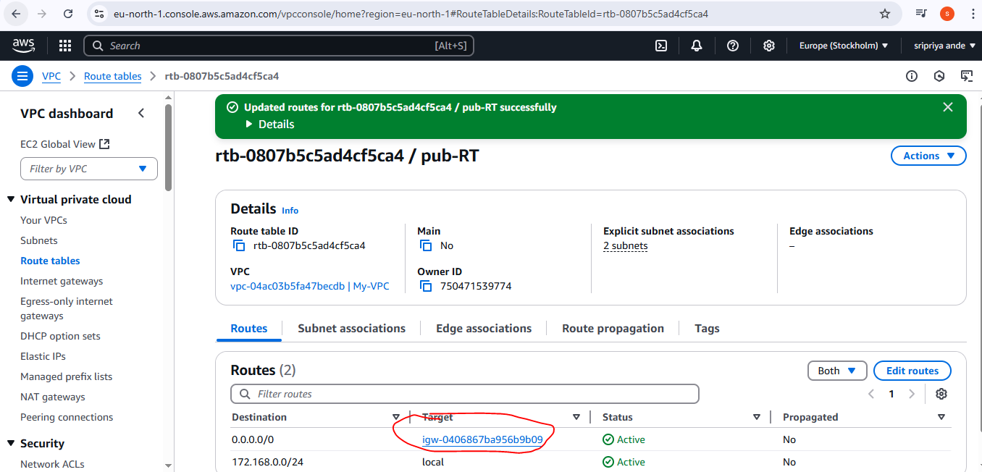

1. **Public route table will have the routes to internet and local**

**step-by-step guide to launch an EC2 instance in a public subnet with internet access:**

Launch EC2 in Public Subnet with Internet Access

**Step 1:** Go to EC2 Dashboard

Open the AWS Management Console.

Navigate to EC2 under "Compute".

**Step 2:** Launch a New Instance

Click "Launch Instance".

Set the Name (e.g., MyVPC).

Select an Amazon Machine Image (AMI) (e.g., Amazon Linux 2023).

**Step 3:** Choose Instance Type

Choose t2.micro (Free Tier eligible).

**Step 4:** Configure Network Settings

VPC: Select MyVPC.

Subnet: Choose one of your Public Subnets.

Auto-assign Public IP: Set to "Enable" ✅

(This step is essential to access the instance from the internet)

**Step 5:** Configure Security Group

Choose "Select existing security group" or create a new one.

If using default:

Ensure it allows inbound SSH (port 22).

Optionally allow All traffic (not recommended for production).

Click Save or Next.

**Step 6:** Key Pair

Select an existing key pair (or create a new one) for SSH access.

A .pem file will be downloaded if you create a new one.

**Step 7:** Launch the Instance

Click "Launch Instance".

Step 8: Connect Using Git Bash

Open Git Bash on your PC.

Run the SSH command (copy from AWS → "Connect" → "SSH" tab):

ssh -i your-key.pem ec2-user@<your-public-ip>

Accept the connection prompt.

You are now connected to your EC2 instance in the public subnet example :ping google.com

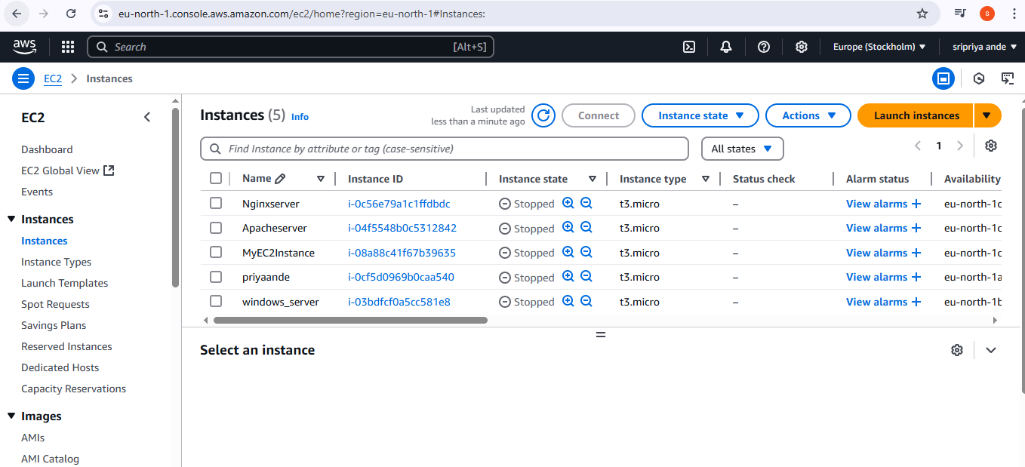

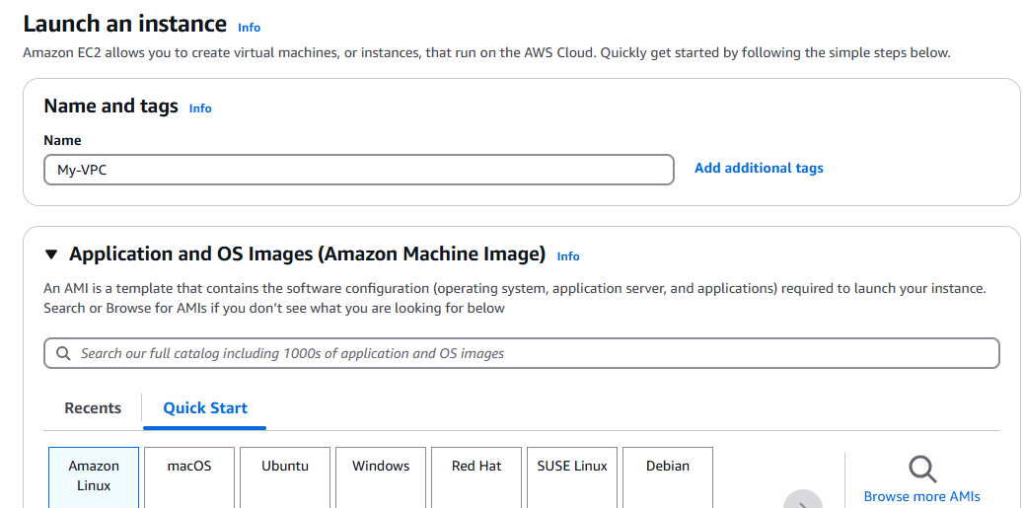

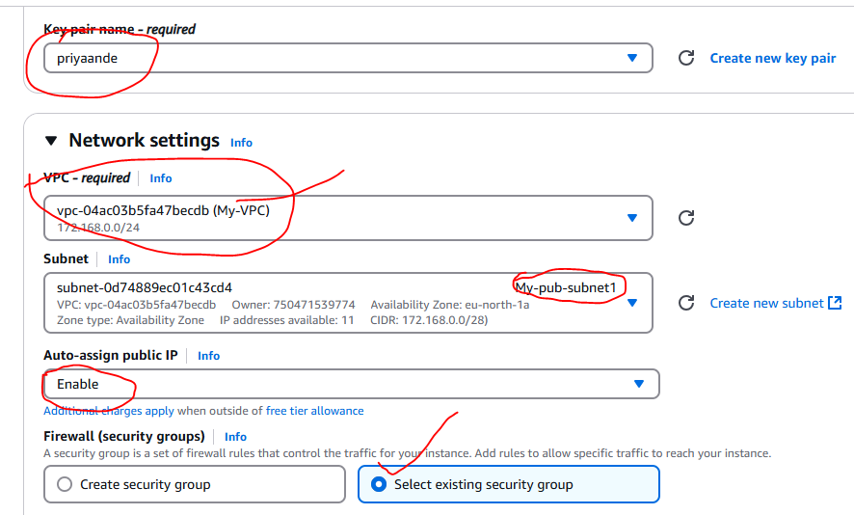

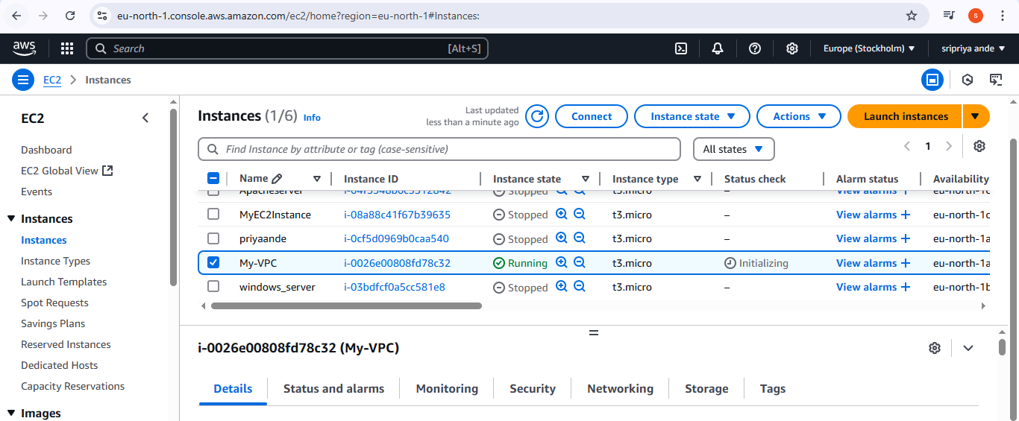

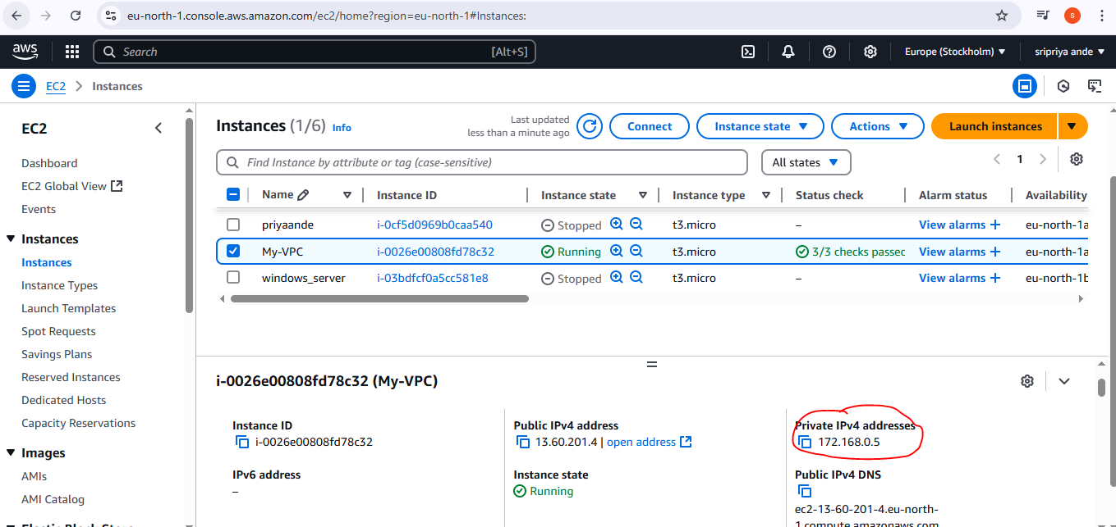

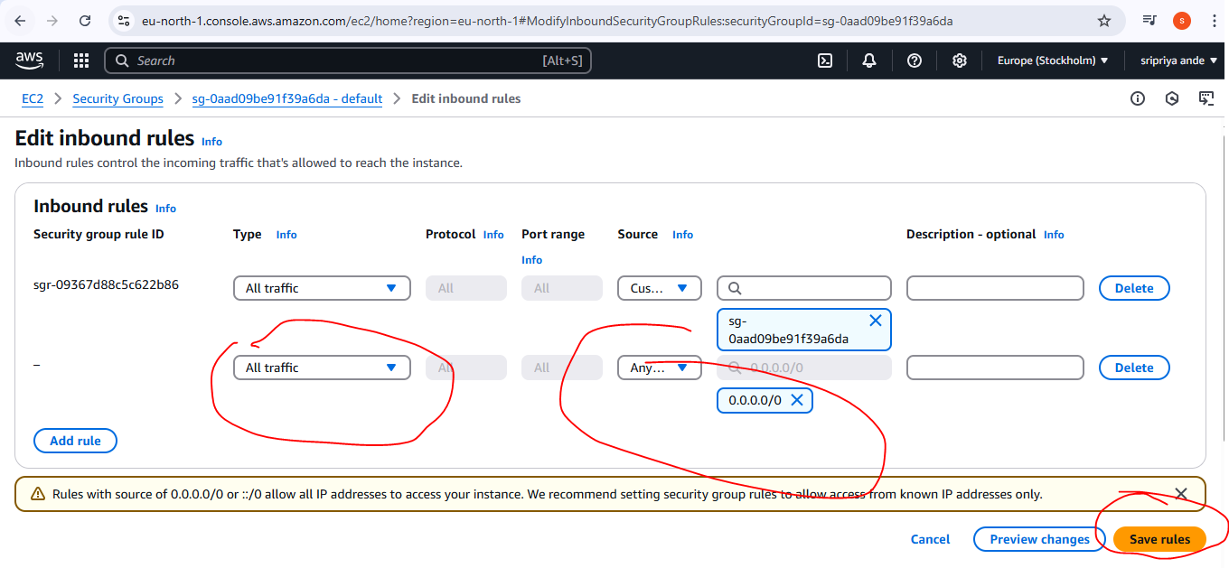

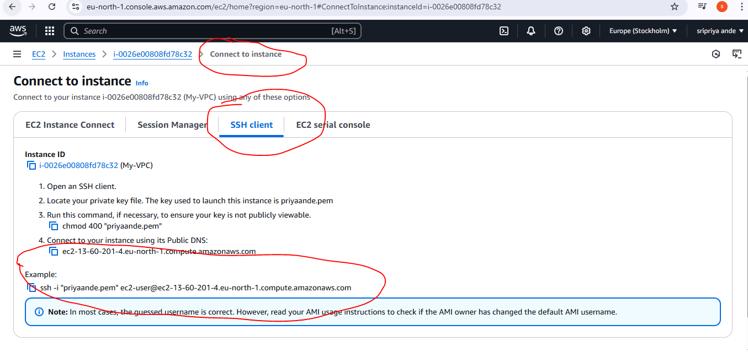

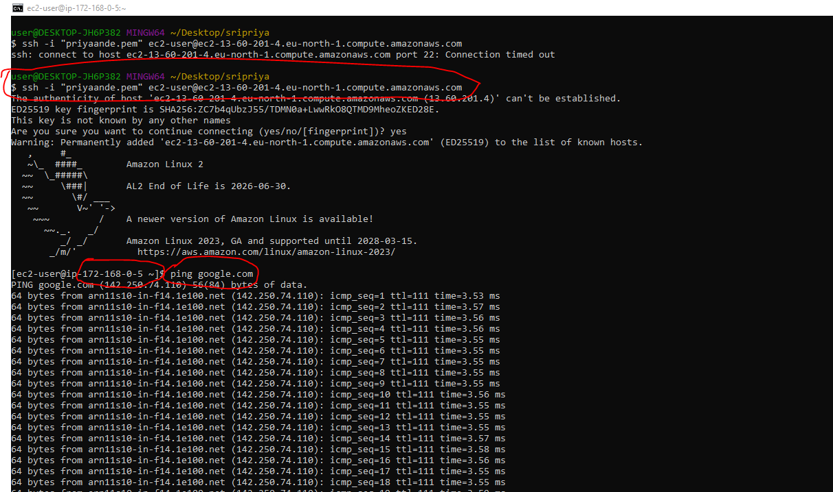

1. **Create Ec2 in public subnet with t2micro and install php**

**Step-by-Step: Launch EC2 in Public Subnet and Install PHP**

**Step 1:** Go to EC2 Dashboard

Open AWS Console.

Search for EC2 in the Services.

Click on “Launch Instance”.

**Step 2:** Configure EC2 Instance

Name your instance:

Amazon Machine Image (AMI): Choose

Amazon Linux 2 AMI (HVM), SSD Volume Type

Instance Type:

t2.micro (Free Tier eligible)

**Step 3:** Configure Network Settings

VPC: Select your custom VPC (e.g., MyVPC)

Subnet: Select your Public Subnet (e.g., Public-Subnet-1)

Auto-assign Public IP: ✅ Enable

Leave rest as default.

**Step 4:** Add Storage

Keep default 8 GiB or customize.

**Step 5:** Configure Security Group

Create new or select existing security group.

Allow the following Inbound Rules:

SSH → Port 22 → Source: My IP

HTTP → Port 80 → Source: 0.0.0.0/0

**Step 6:** Key Pair

Select existing key pair or create a new one.

Download the .pem file (if new).

Click Launch Instance.

**Step 7:** Connect to EC2

Open Git Bash or terminal.

Connect using:

ssh -i "your-key.pem" ec2-user@<Public-IP>

**Step 8:** Update System

sudo yum update -y

**Step 9:** Install Apache Web Server

sudo yum install httpd -y

sudo systemctl start httpd

sudo systemctl enable httpd

**Step 10:** Install PHP

sudo amazon-linux-extras enable php7.4

sudo yum clean metadata

sudo yum install php php-cli -y

**Step 11:** Create PHP Test File

echo "<?php phpinfo(); ?>" | sudo tee /var/www/html/info.php

**Step 12:** Test in Browser

**Go to:**

http://13.60.201.4/info.php

You should see the PHP info page.

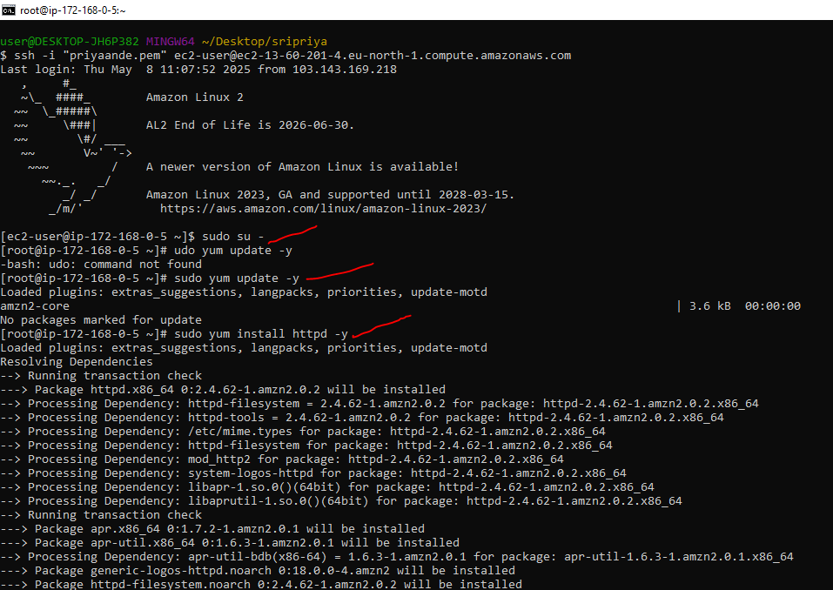

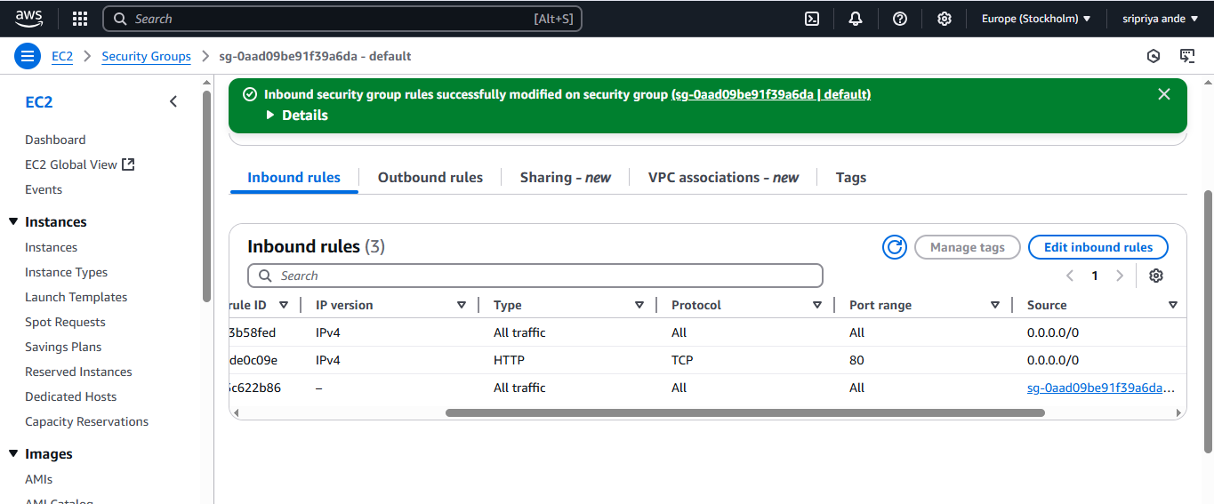

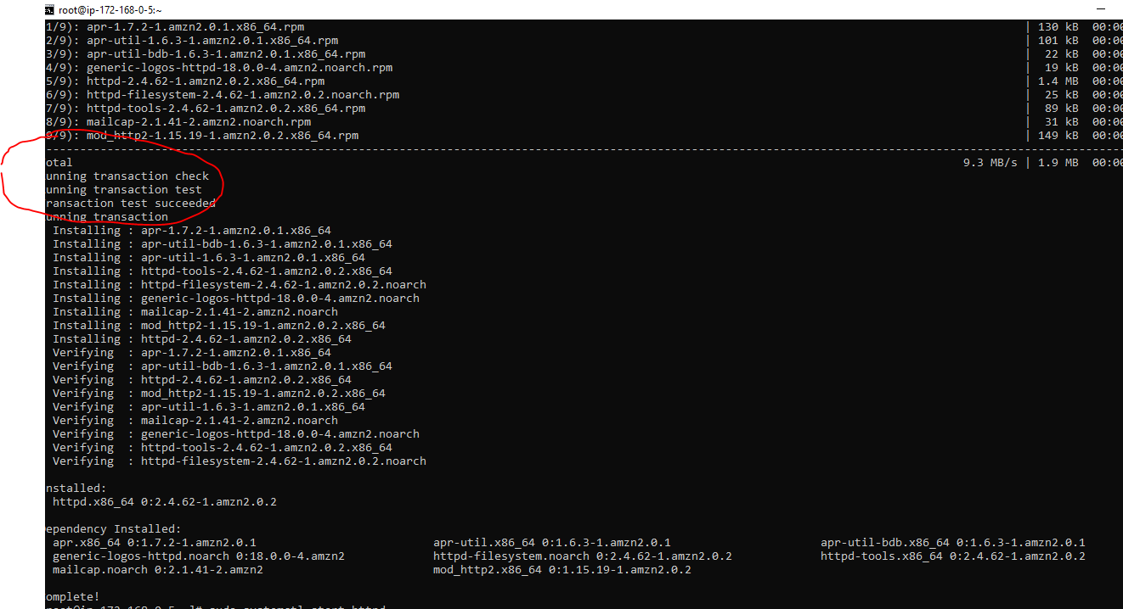

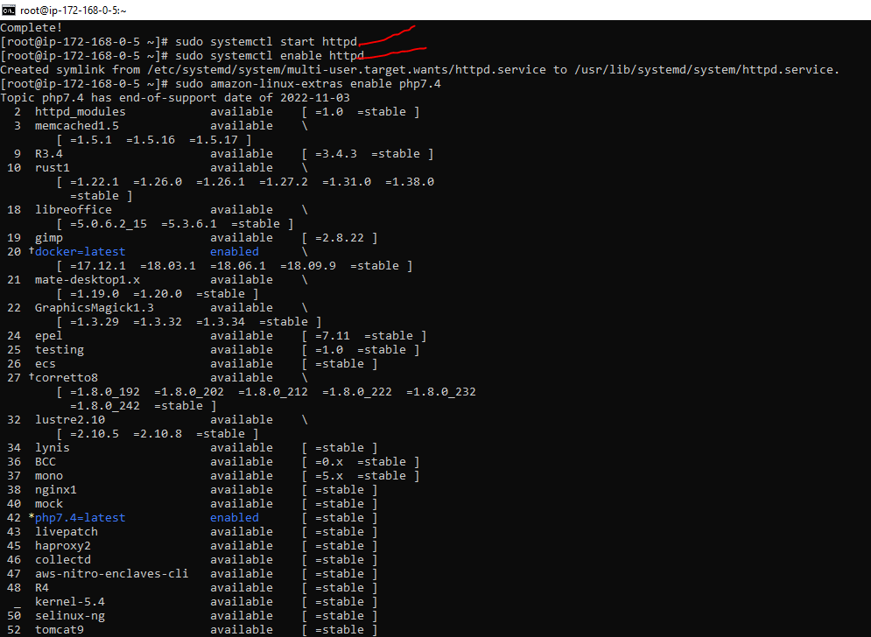

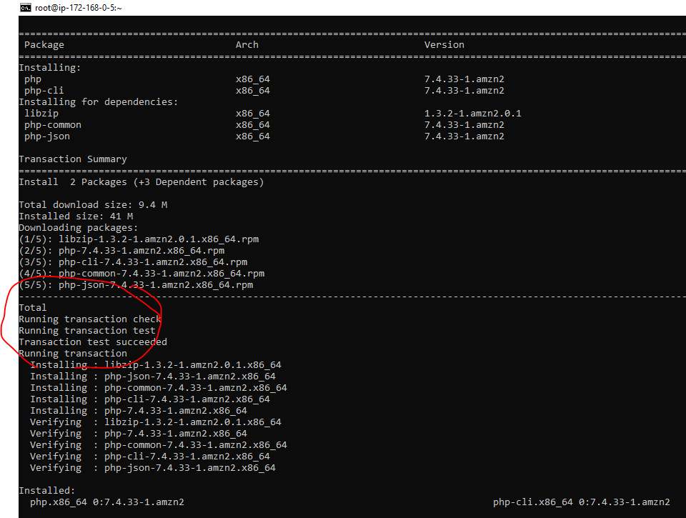

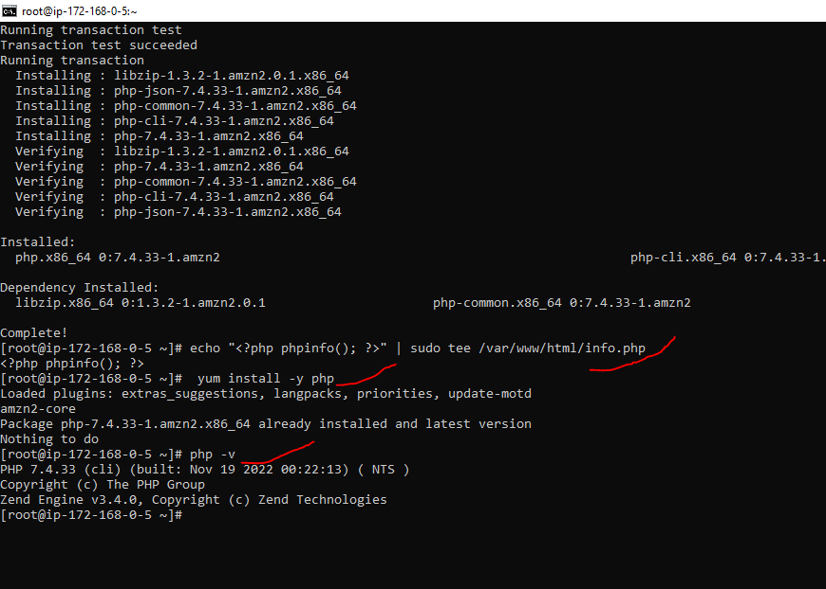

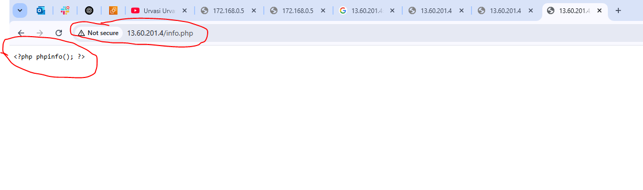

1. **COnfigure Nat gateway in public subnet and connect to private Instance**

Create an EC2 instance in a private subnet

Set up a NAT Gateway for internet access

SSH into the private EC2 using Git Bash

**Part 1:** Create EC2 in a Private Subnet

**1. Create or Use an Existing VPC**

Go to VPC Dashboard → Create VPC

**CIDR block:** 10.0.0.0/16

**2. Create Two Subnets**

Public Subnet (e.g. 10.0.1.0/24)

Private Subnet (e.g. 10.0.2.0/24)

**3. Create and Attach Internet Gateway**

Go to Internet Gateways → Create one

Attach it to your VPC

**4. Create Route Tables**

Public Route Table: Add route 0.0.0.0/0 → Internet Gateway

Associate it with the public subnet

Private Route Table:

Initially, no route to internet (we’ll update it after creating the NAT Gateway)

Associate it with the private subnet

**5. Launch EC2 Instances**

Launch one EC2 instance in the public subnet (Bastion Host)

Give it a public IP

Attach key pair (e.g., my-key.pem)

Launch one EC2 instance in the private subnet

No public IP

Attach the same key pair or another if needed

**Part 2:** Create and Attach a NAT Gateway

1. Allocate Elastic IP

Go to Elastic IPs → Allocate

2. Create NAT Gateway

Go to NAT Gateways

Select the public subnet

Use the Elastic IP you allocated

3. Update Route Table for Private Subnet

Go to the private route table

Add route:

Destination: 0.0.0.0/0

Target: NAT Gateway

**Part 3:** SSH Using Git Bash (from your local machine)

1. SSH into the Bastion (Public EC2)

ssh -i "my-key.pem" ec2-user@<Public-IP-of-Bastion-EC2>

Replace ec2-user with your instance's OS default user:

Amazon Linux: ec2-user

Ubuntu: ubuntu

RHEL: ec2-user or root

2. Copy Private Key to Bastion EC2

If using a different key for private EC2:

scp -i "my-key.pem" private-key.pem ec2-user@<Bastion-IP>:/home/ec2-user/

Then SSH into bastion and run:

chmod 600 private-key.pem

3. SSH into the Private EC2 (from Bastion)

ssh -i private-key.pem ec2-user@<Private-IP-of-Private-EC2>

Testing Internet Access on Private EC2

Inside the private EC2, try:

ping google.com

sudo yum update -y(if using Amazon Linux)

If this works, your NAT Gateway is correctly configured.

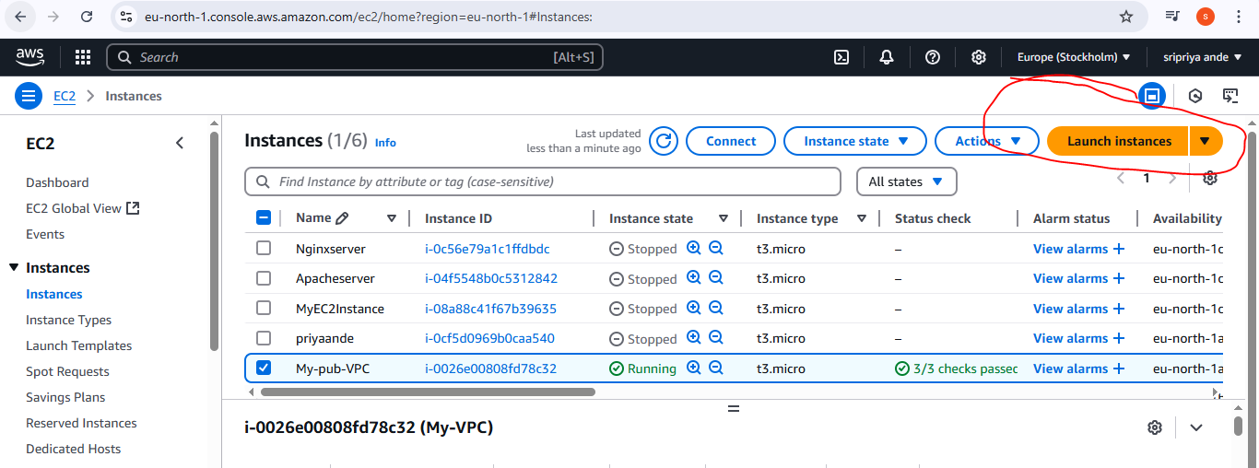

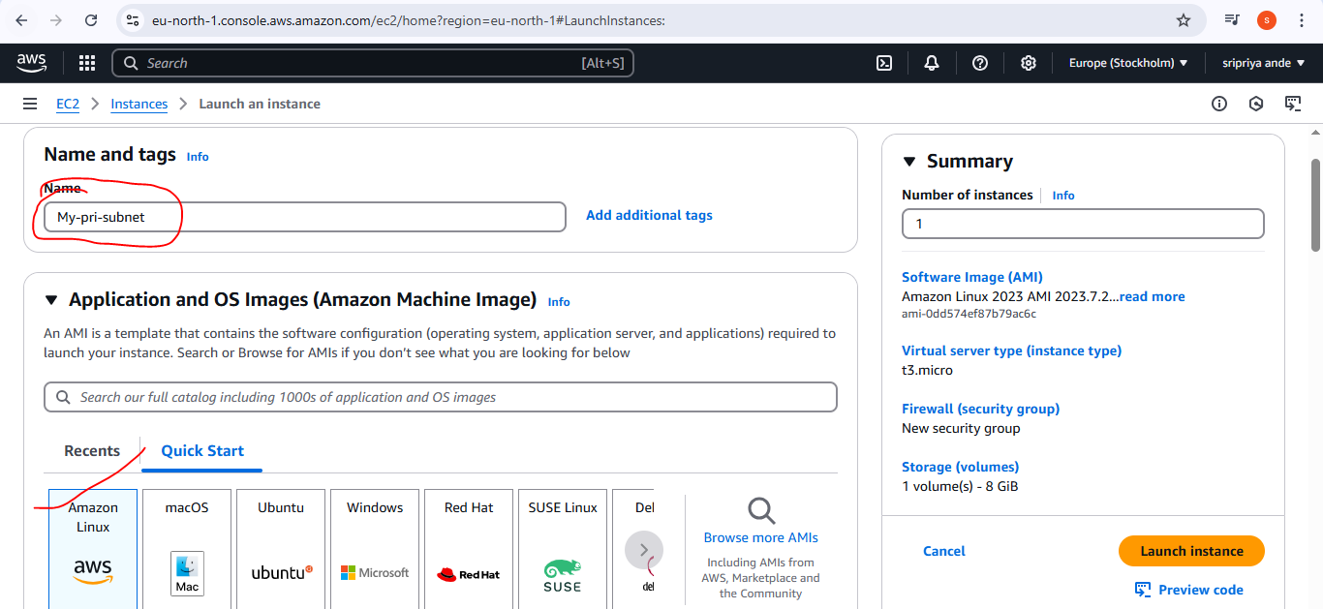

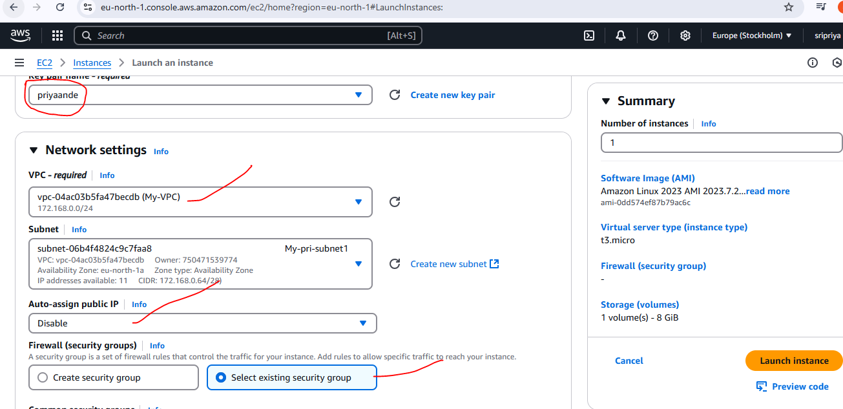

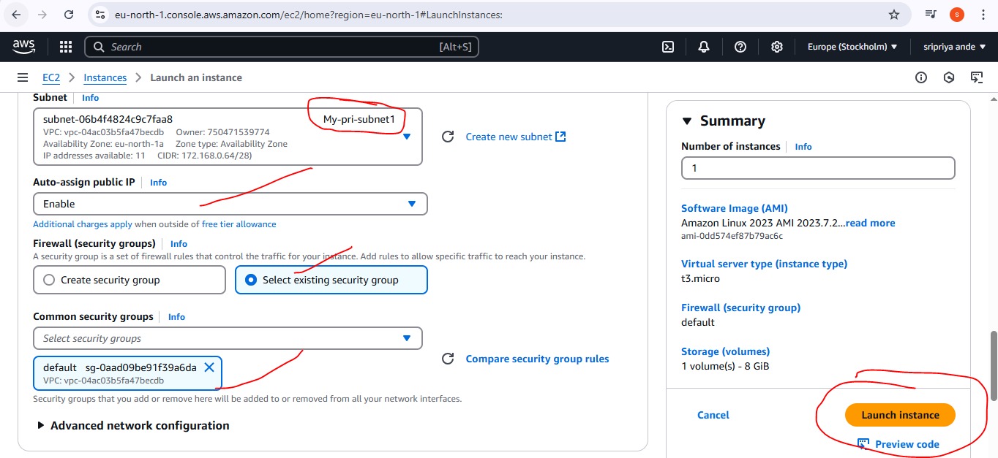

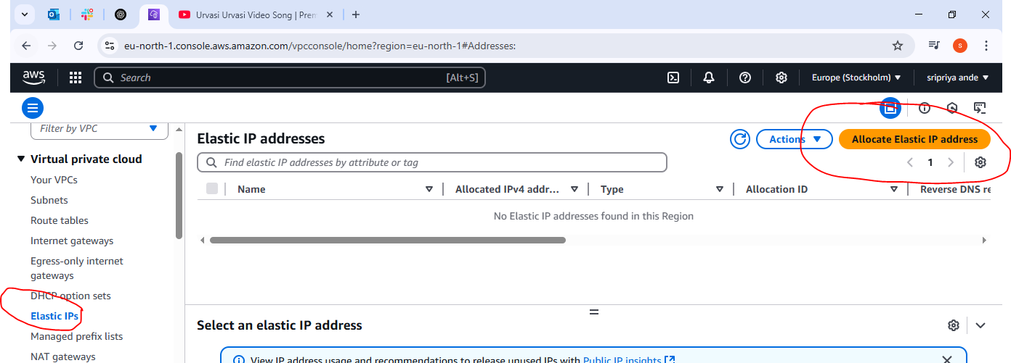

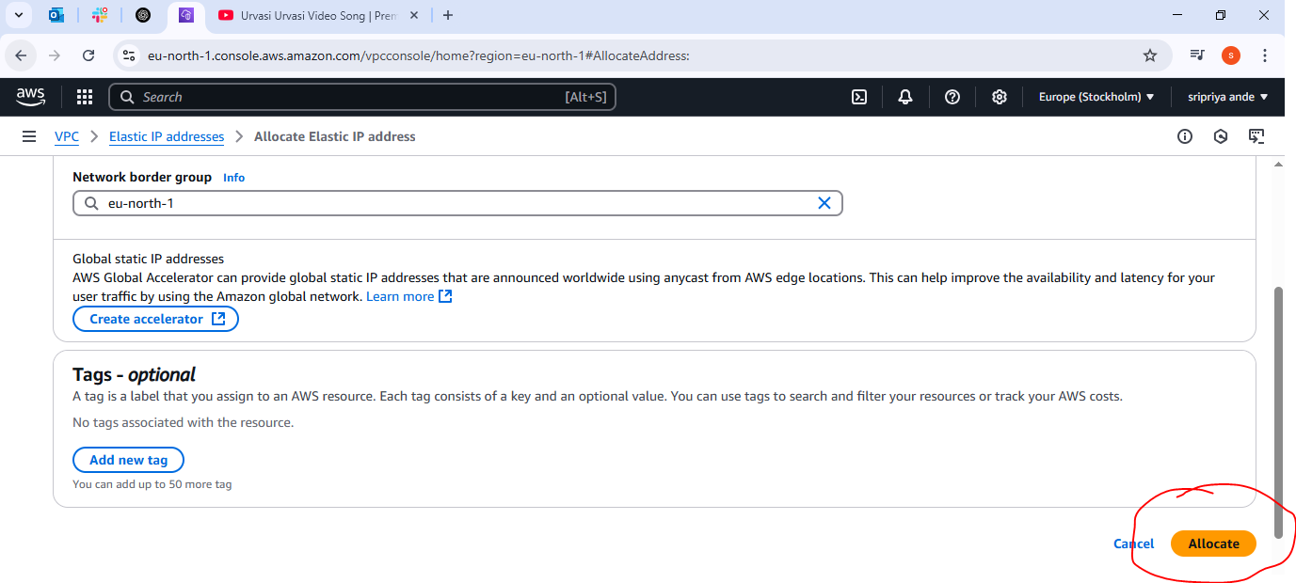

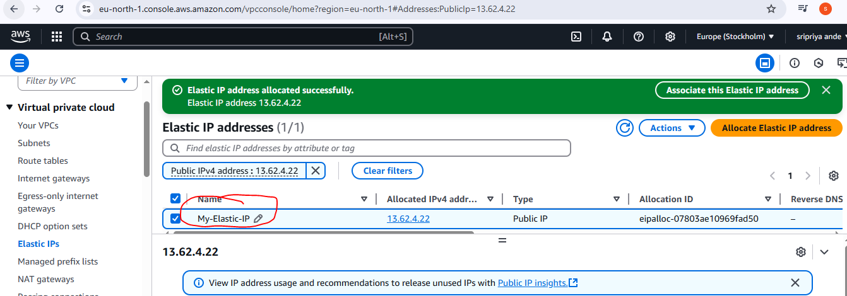

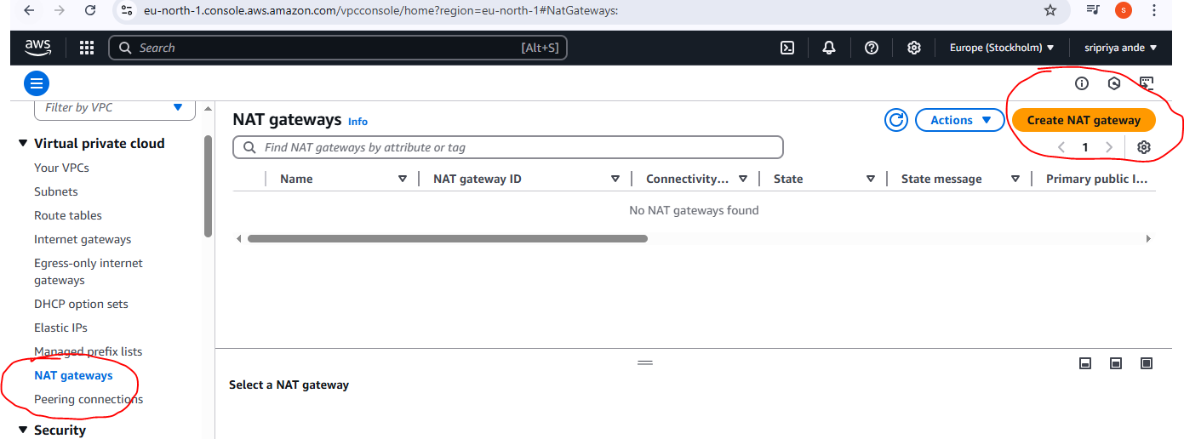

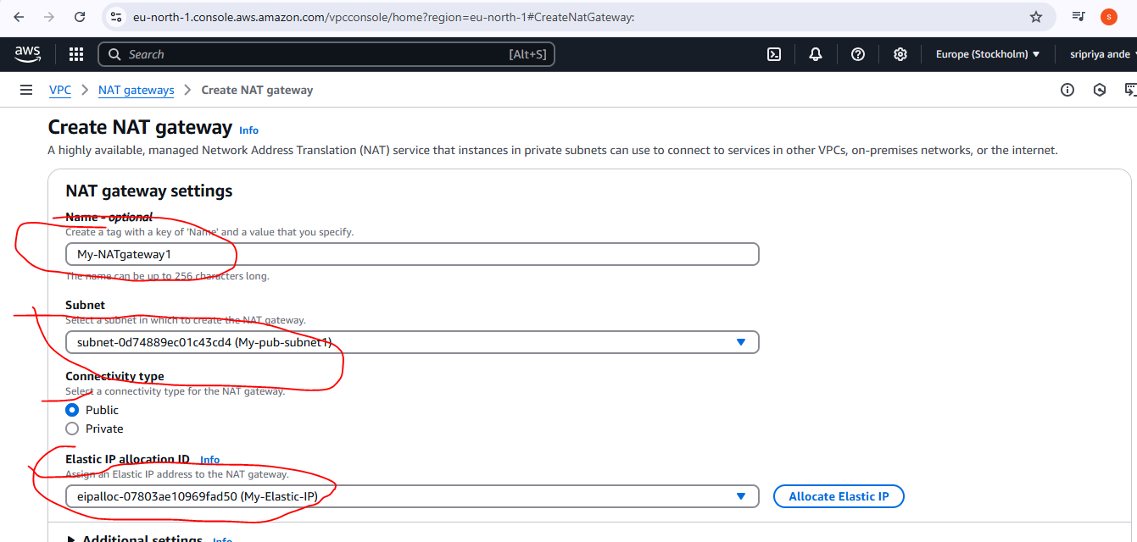

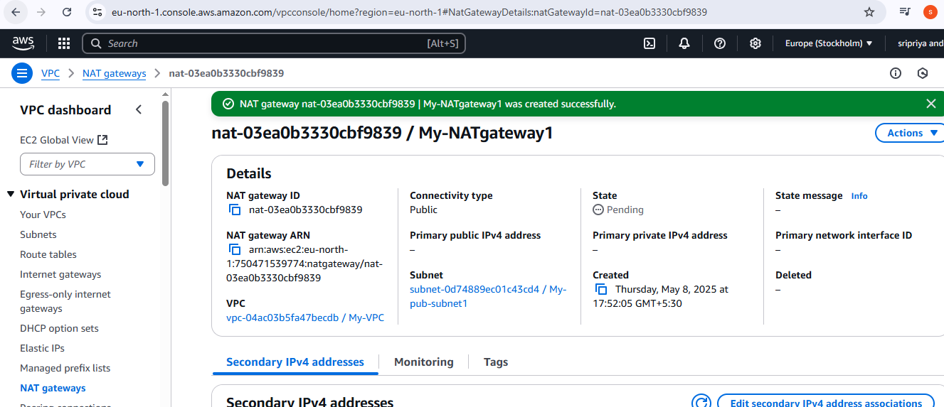

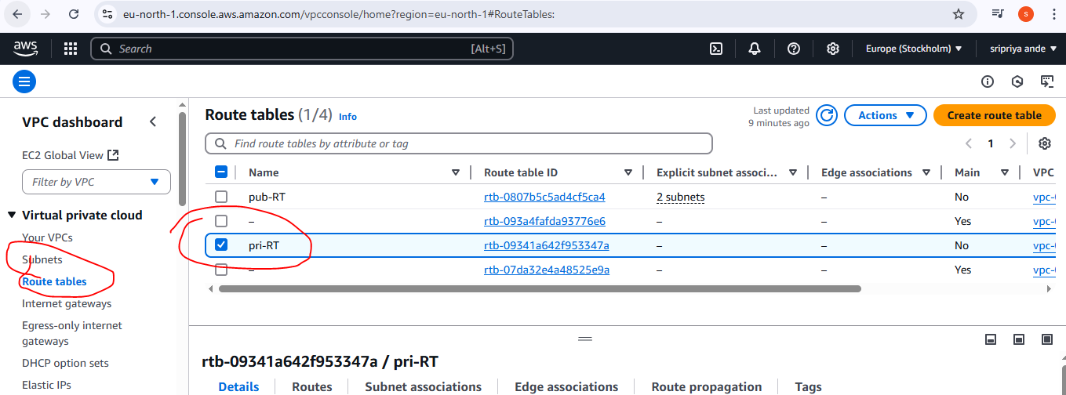

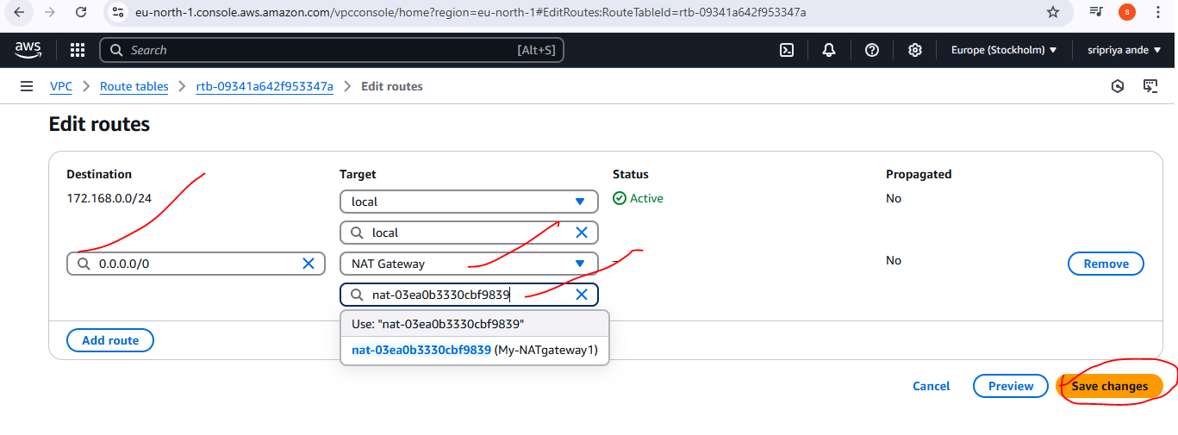

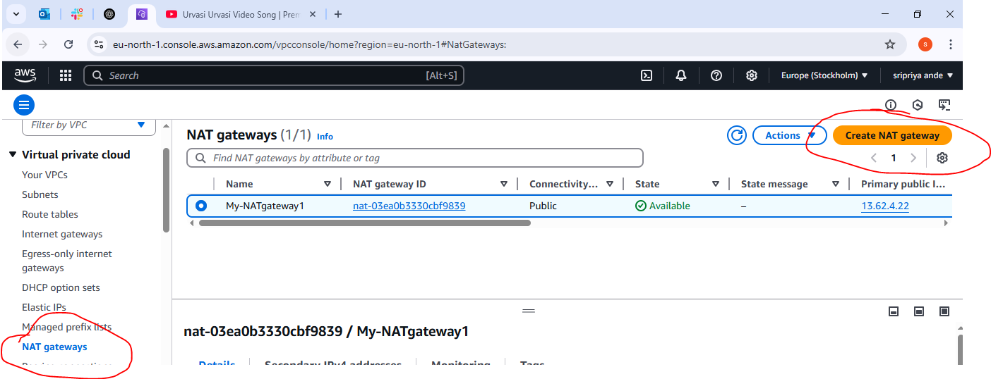

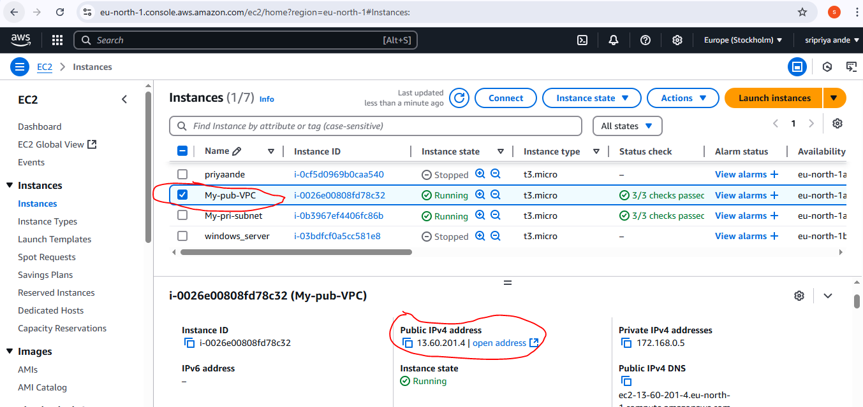

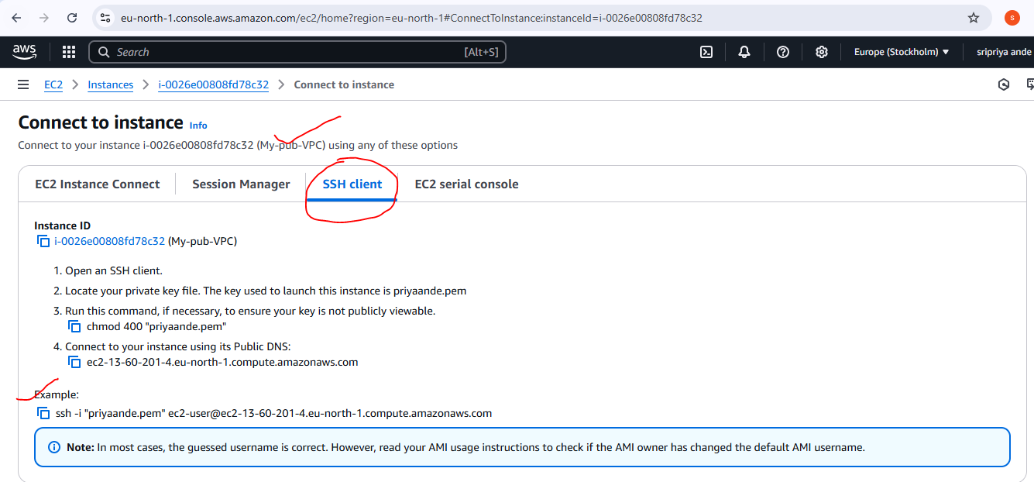

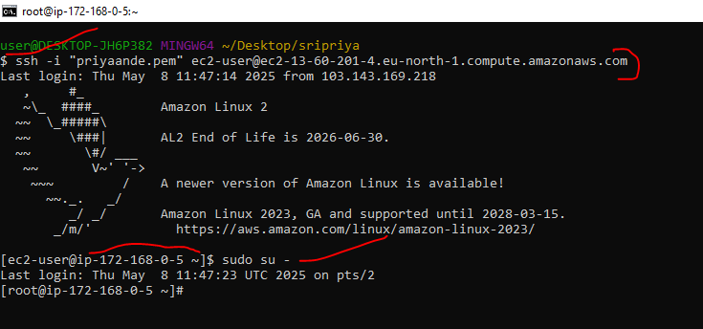

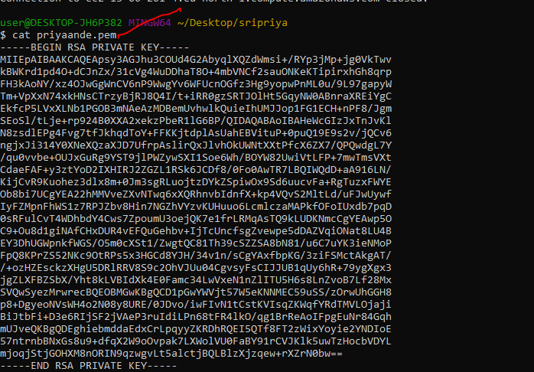

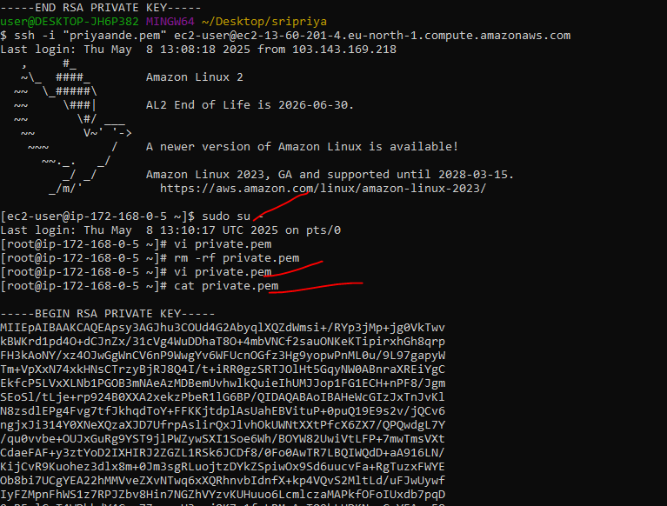

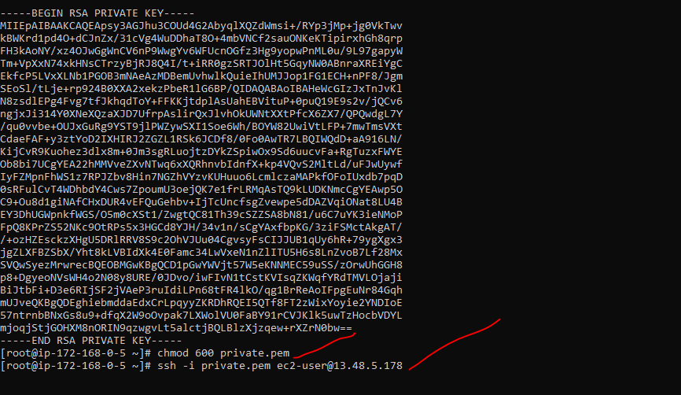

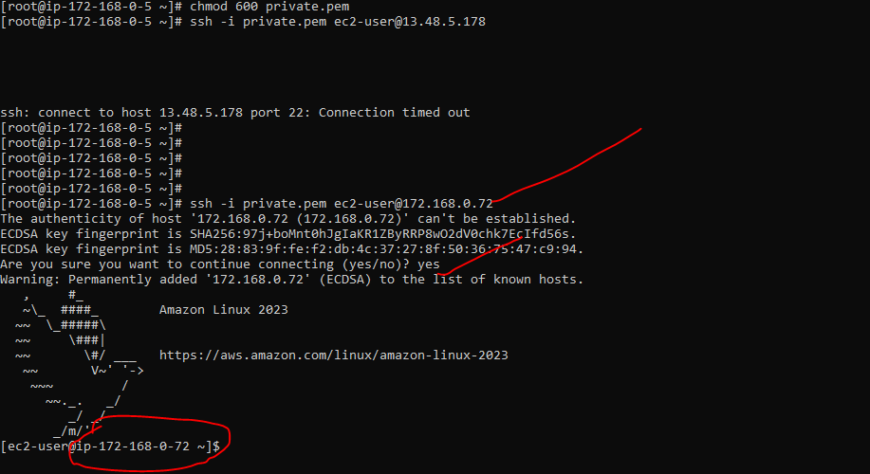

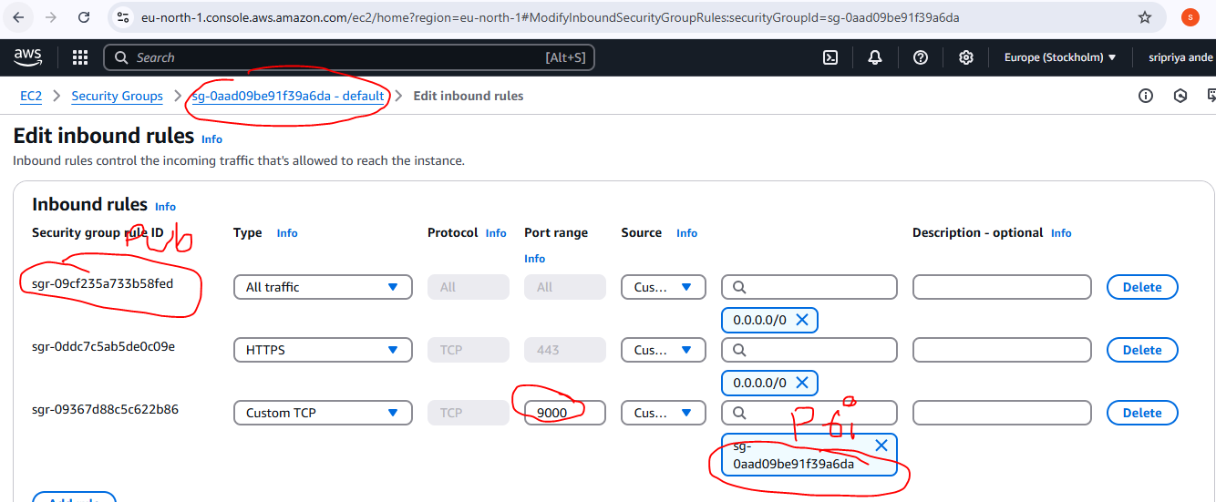

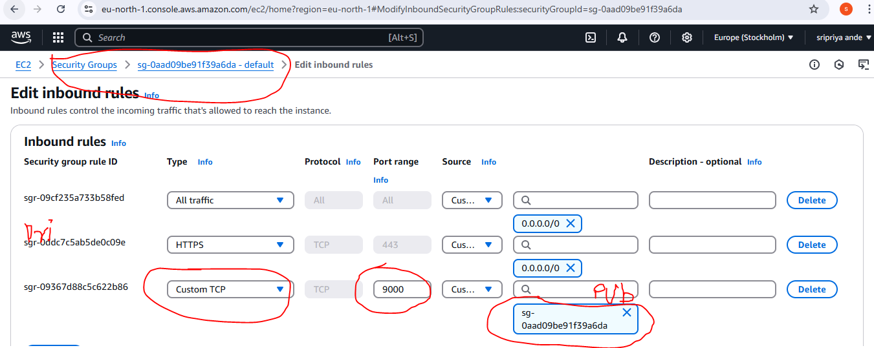

To get internet access we need to set in route table as main in private subnet

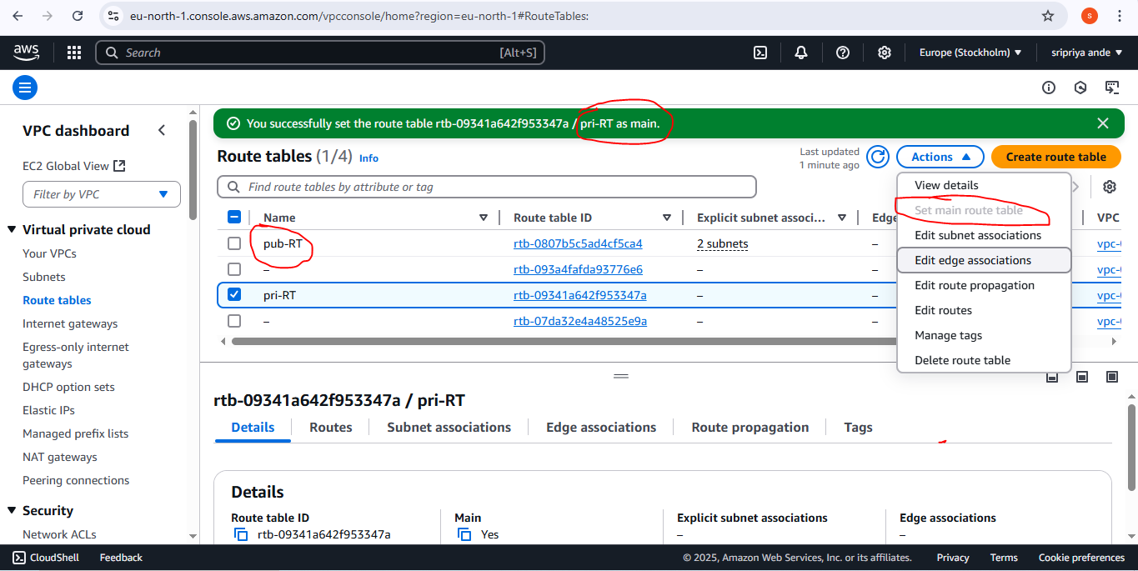

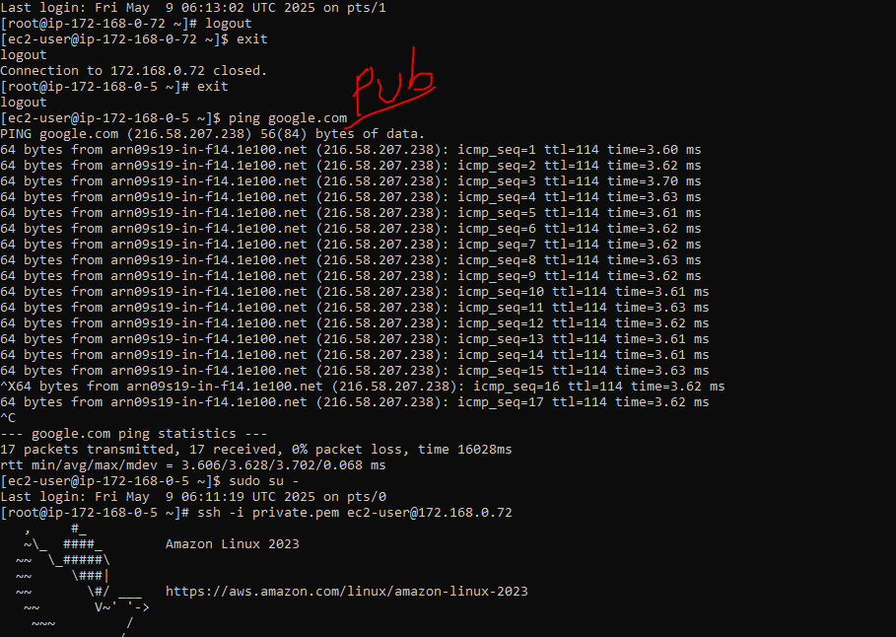

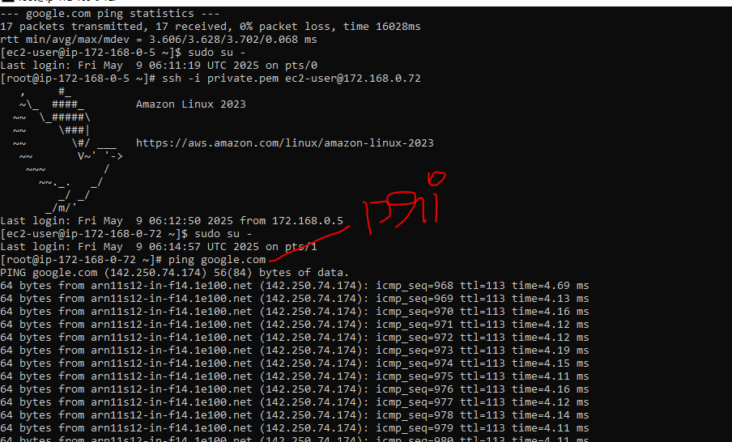

1. **Install Apache Tomcat in private ec2 and deploy a sample app.**

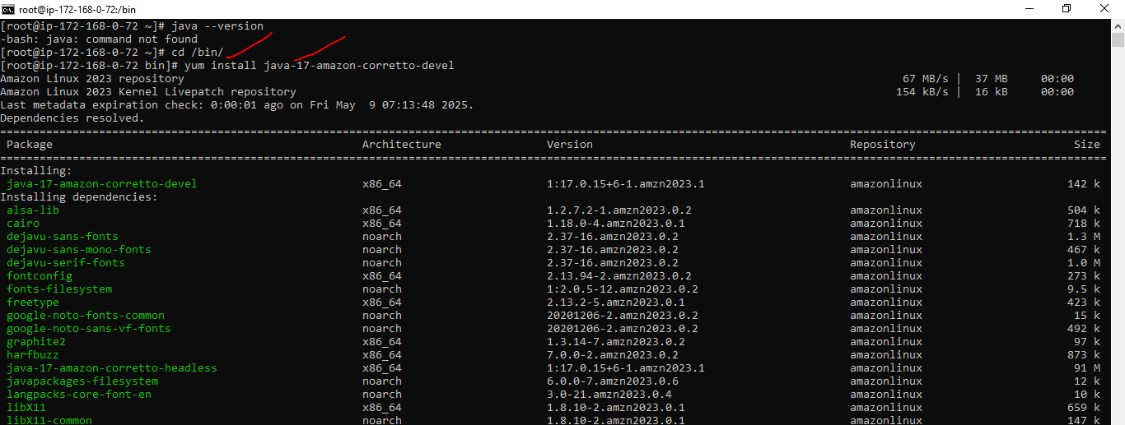

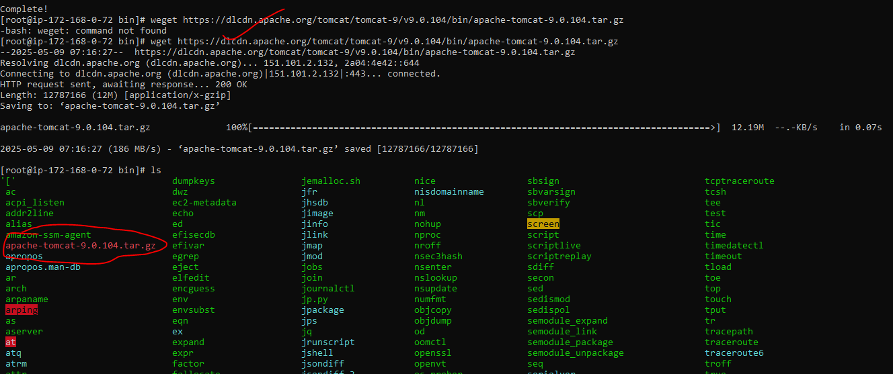

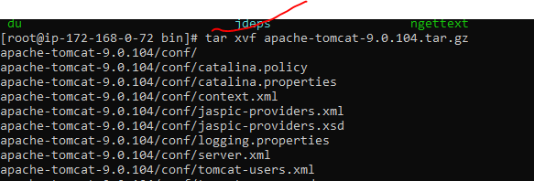

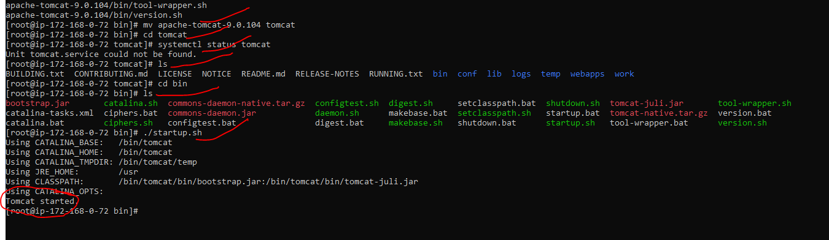

1. **COnfigure VPC flow logs and store the logs in s3 and cloudwatch.**

**Steps for COnfigure VPC flow logs and store the logs in s3**

* Go to VPC in Yours VPC click on vpc id
* We can find flowlogs
* Click on create flow logs give name tag(eg:my _flowlog)
* Select all
* Minimum 1min
* Destination as S3 bucket now clear on S3 bucket link or we have another way serch s3 on aws consle we will find s3 page click create s3 bucket
* ARN-Amazon resource Number
* Provide bucket name(eg:my-sri-s3 it should be unique)
* All enabled and don’t block nad ackowledge then created s3 bucket in s3 bucket s3 id created and then click and go proprties e can find ARN id copy
* Now go to flowlogs and paste ARN
* Log format-AWS
* Default--text
* Create flowlog----we can see flowlog id
* Now go to see and do some activity and refresh s3 bucket we can see find some log files created
* Click on account id then vpc flowlogs
* And download it will save in your pc or laptop files

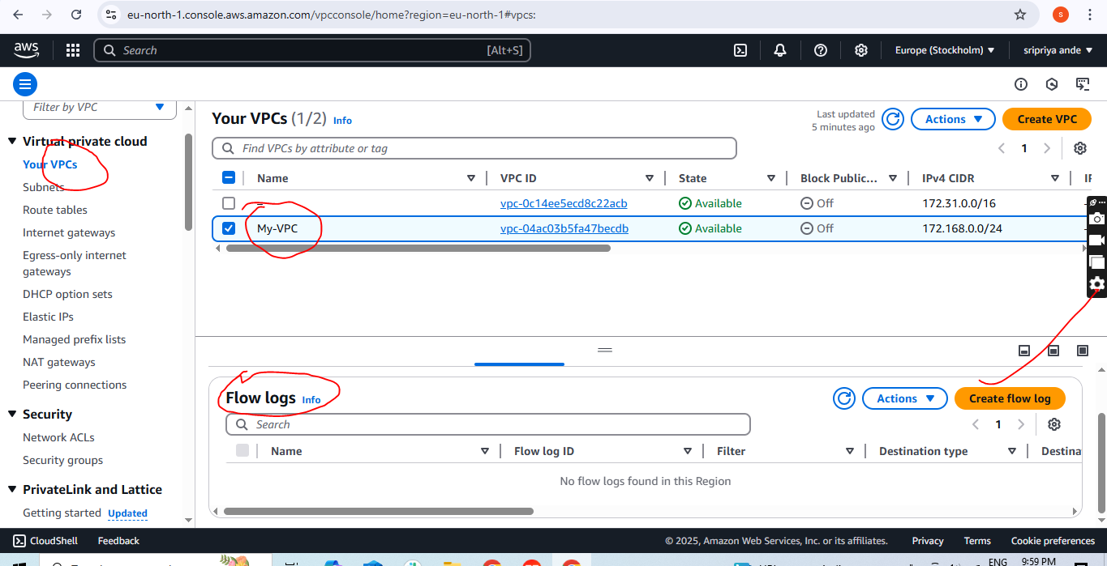

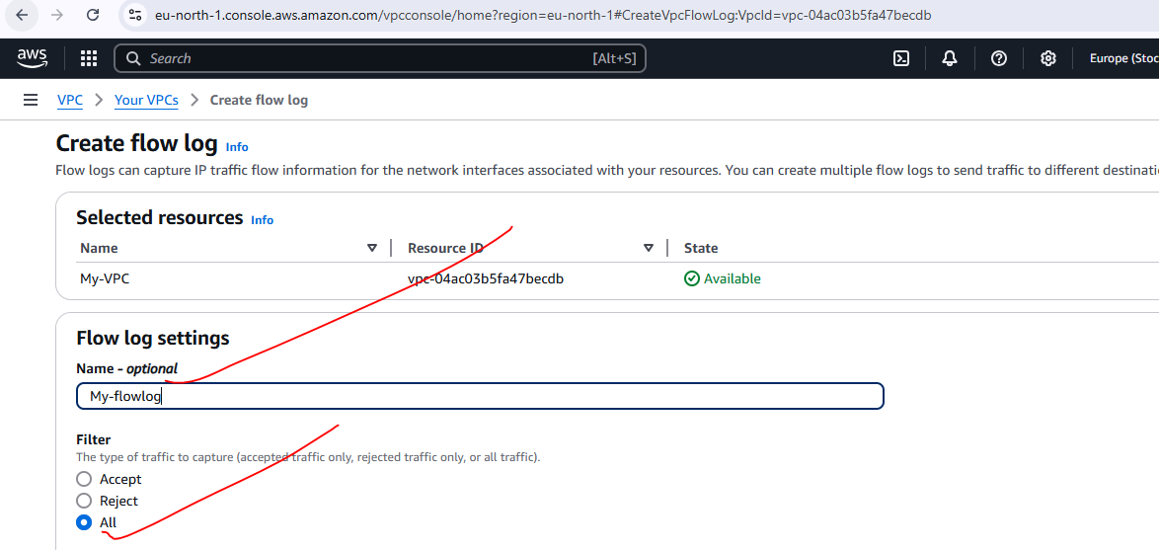

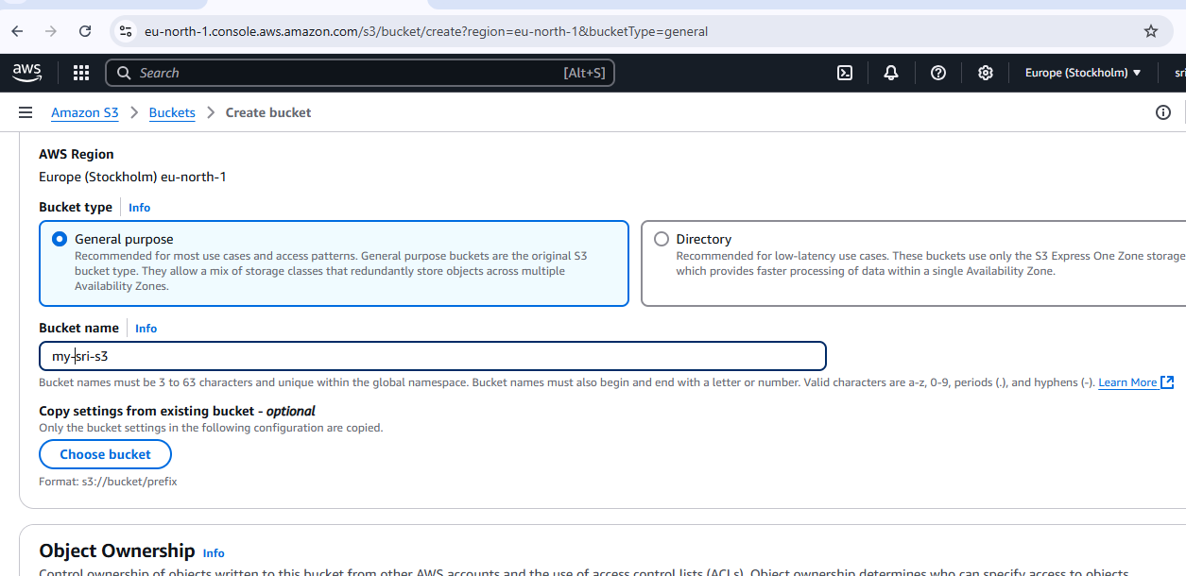

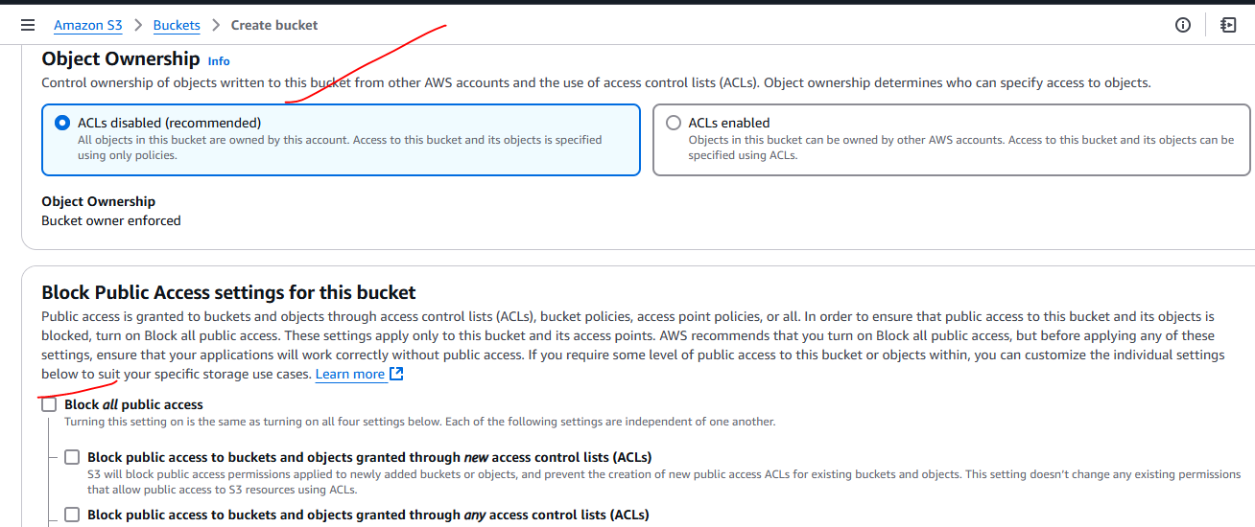

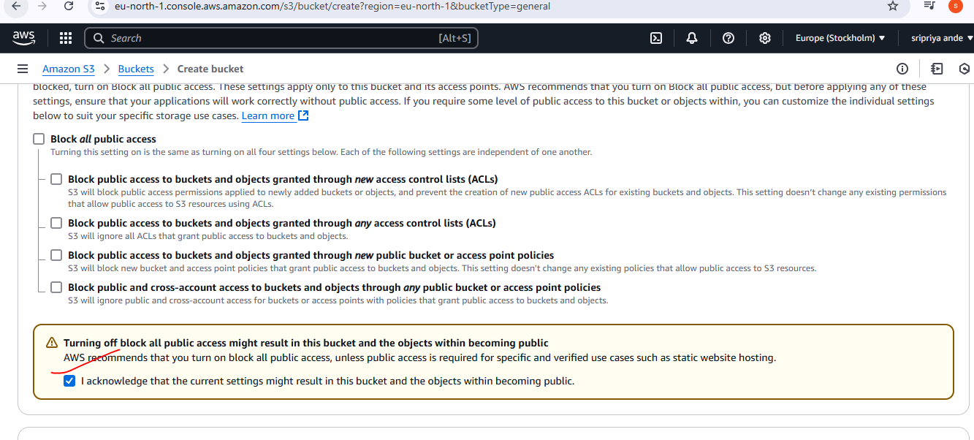

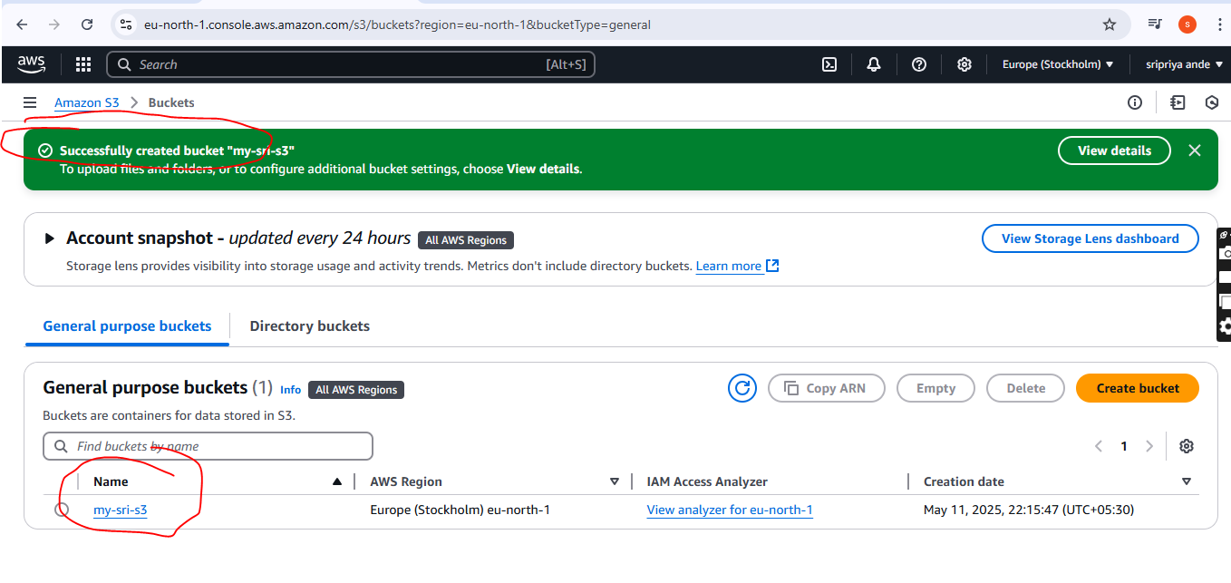

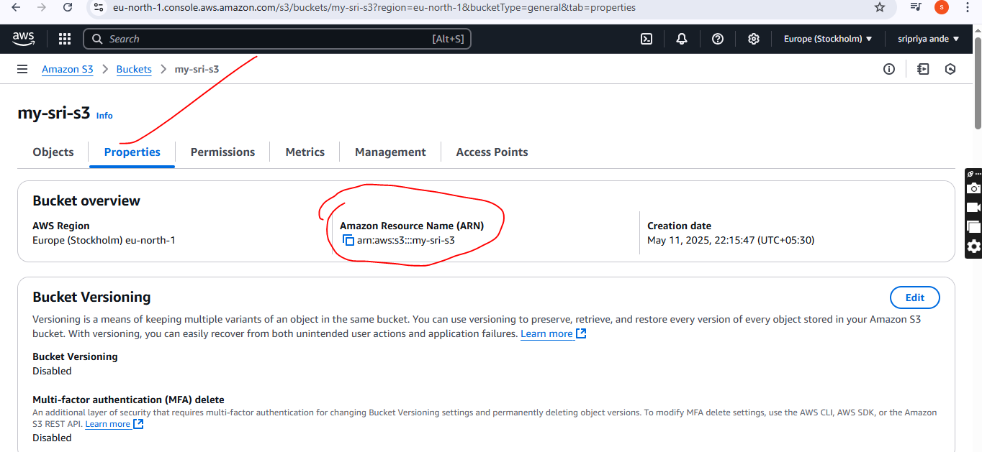

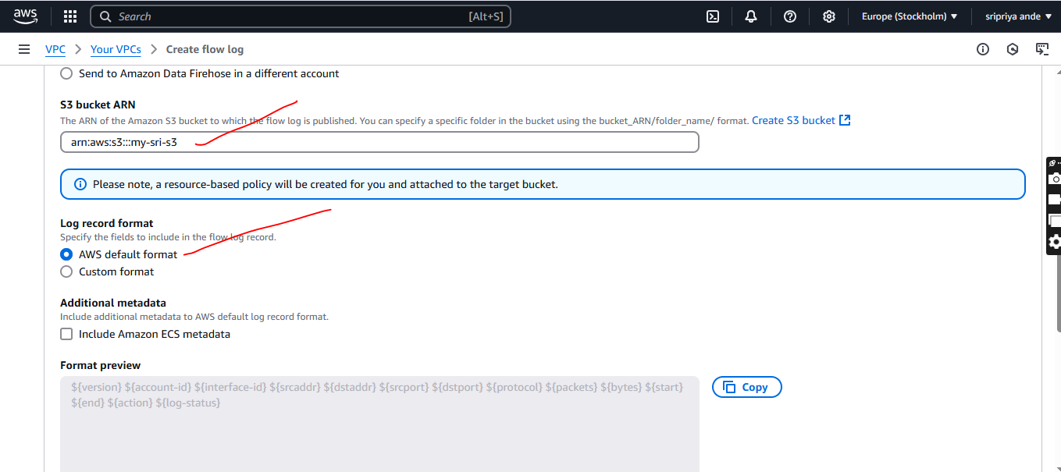

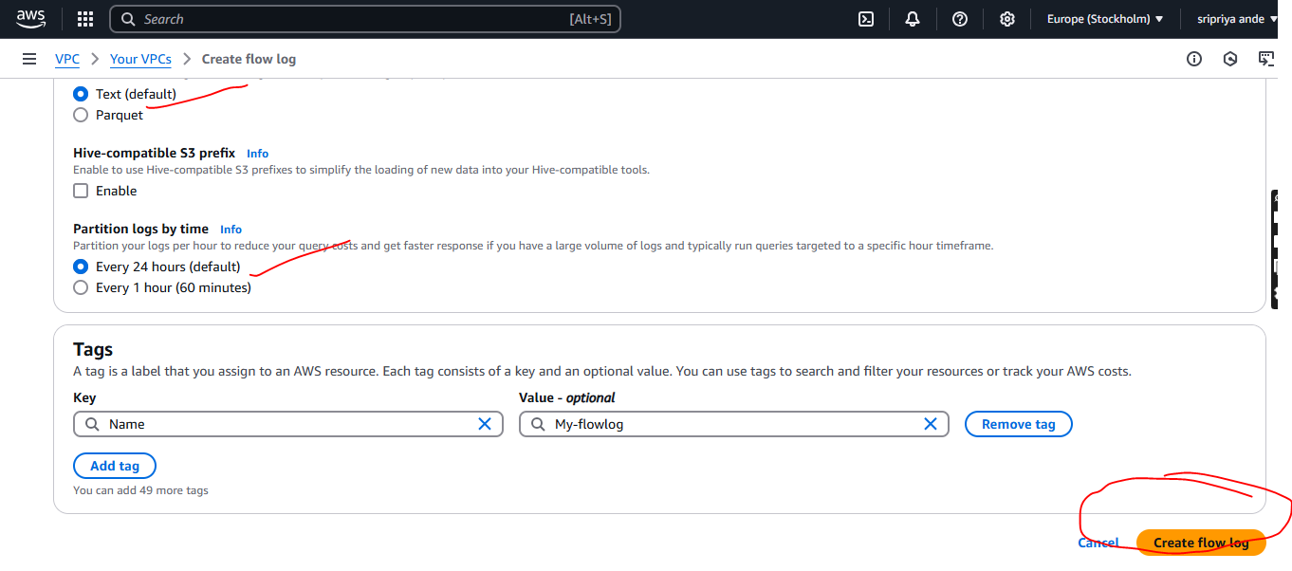

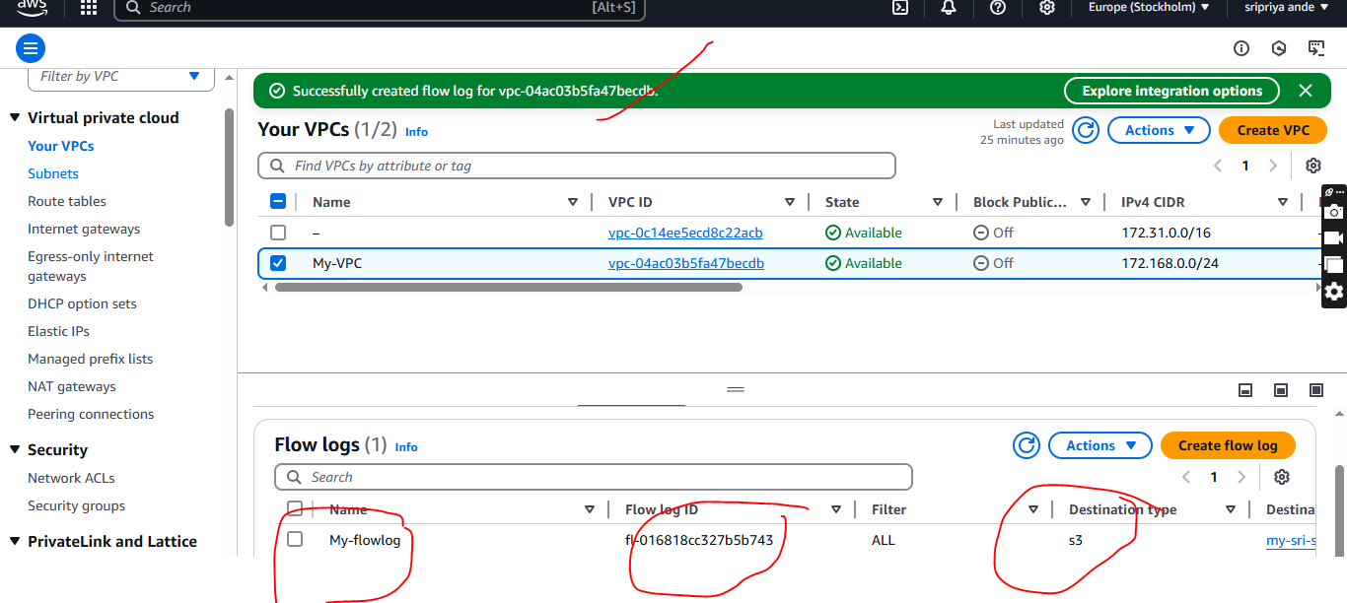

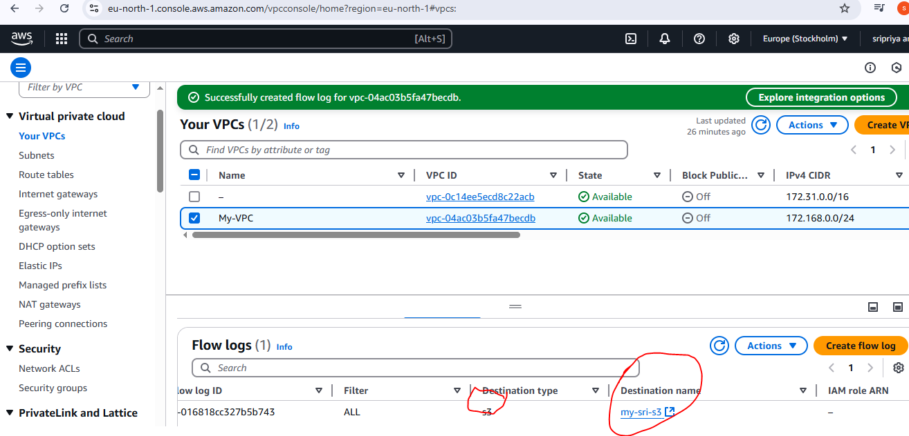

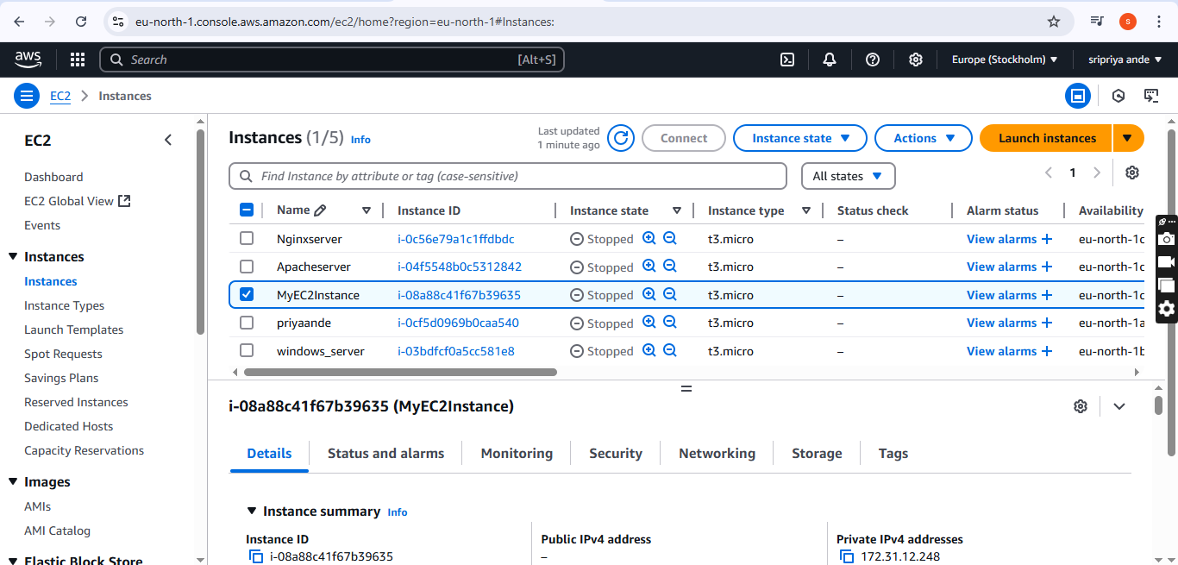

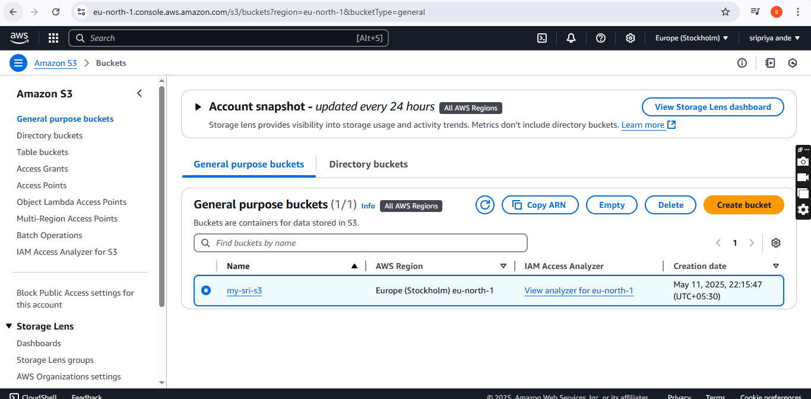

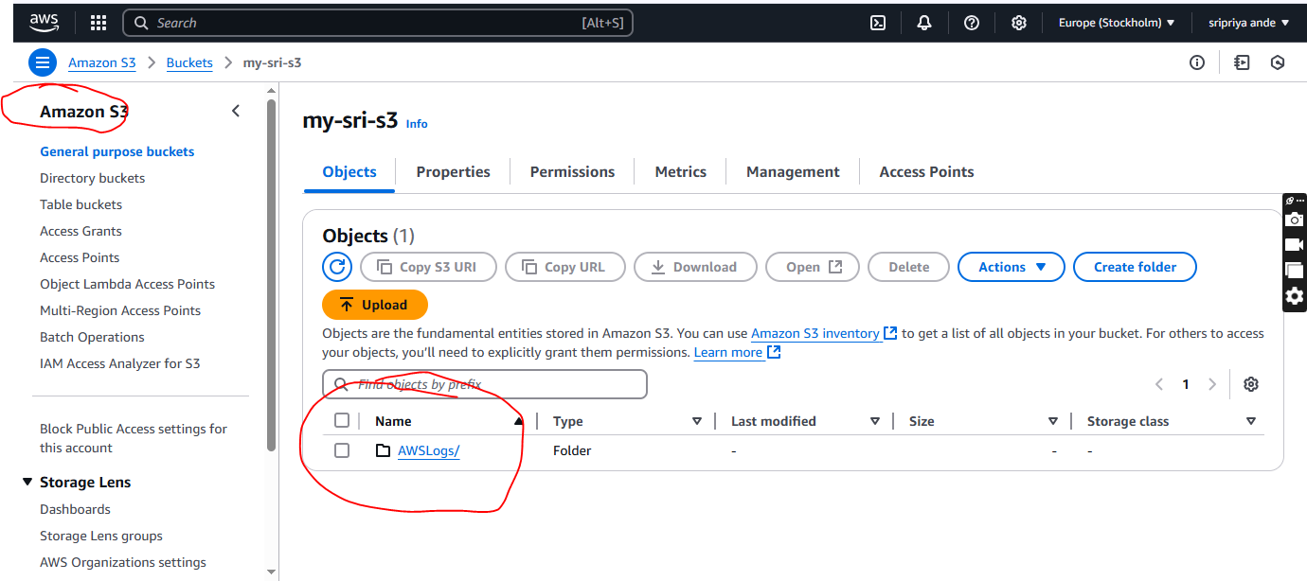

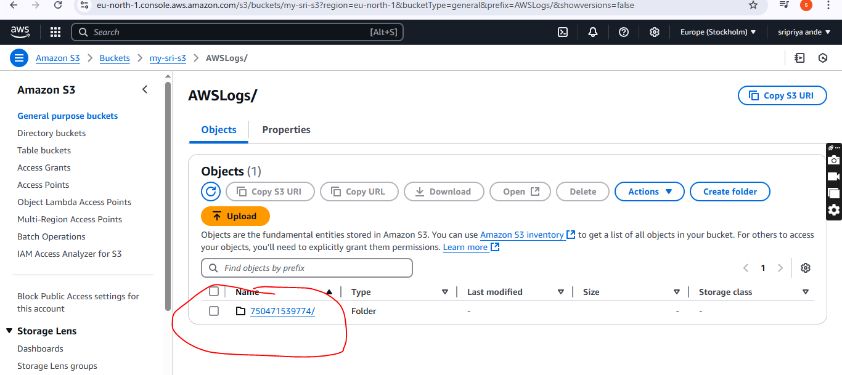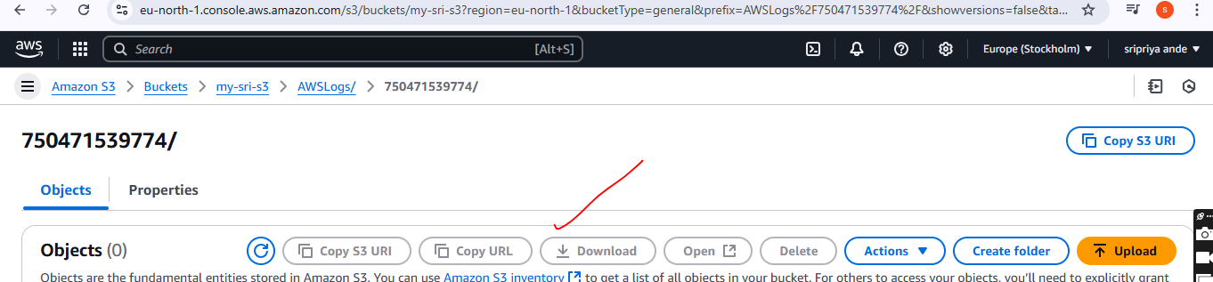

**Stepps for COnfigure VPC flow logs and store the logs in cloudwatch.**

* Go to vpc--flowlogs
* **Create**  one flow logs(eg:My-flowlog-cloudwatch)
* **Select**  all,1min,cloudwatch
* Now go to cloudwatch in log group click on log group
* Destination(Vpc-flowlog-cloudwatch),select never click on create
* Then go to vpc flowlogs and select ARN or log group name
* Then in IAM ----go to IAM
* In IAM in roles and policies provide permission copying from document from aws official doc( <https://docs.aws.amazon.com/vpc/latest/userguide/flow-logs-iam-role.html> )

**Select trust ploicies for role and policies**

* **In policy copy code in json**
* Create role and go vpc serach for role name given and
* Next default and create flowlog for clod watch
* Then go to cloud watch ---->cloud group--->we can see group created and go to log stream
* We can we activity of ec2

